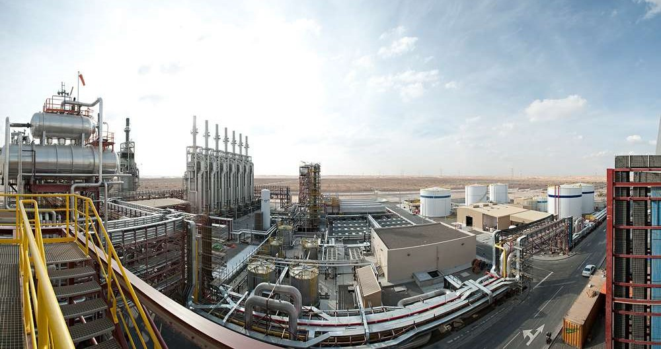

**MAJOR OUTAGE REPORT 2020**

Please note: This document is Shams 1’s property and shall be neither partially or completely published nor duplicated without written authorization.

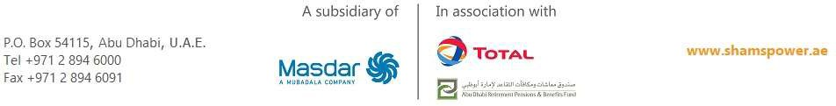

Message from General Manager



The major outage has a significant importance to the long term strategy of Shams plant and assets. The vast scope includes major overhaul and inspection of critical equipment such as

steam turbine, generator, booster heaters, HTF heaters, DCS upgrade and others. These are critical assets and equipment that impact the business of Shams directly, thus it’s of paramount importance to ensure its reliability, availability, and efficiency over its lifetime.

There were many factors that contributed to the success of major outage. Some of those were preparation and planning, procurement and contracting, vendors and contractors management. Shams team made great efforts to ensure all these factors successfully completed in a timely manner.

This was the first major outage in Shams history and we all had a big pressure to demonstrate our competency, high performance and timely completion of this goal. The total investment and the duration of the outage has added more pressure from a financial perspective.

Managing the engagement of over 400 people at site and over 191,000 work-man hours presented unparalleled safety and operational challenge. Additionally, the circumstances that was forced upon us due to COVID-19 with the panic around the world, uncertainties, and psychological impact on everyone; added greater challenges and pressure on everyone. I am proud to state that our HSE records were excellent, and that we successfully implemented all precautionary measures recommended. Since our people are our greatest asset, I am pleased to confirm that there was no single case of major HSE incident reported which is complementing our outstanding record of no LTI since January 2016.

All technical challenges, unexpected deficiencies, challenges of managing multiple contractors, dealing with conflicts, and addressing some vendor’s incompetence’s were some of the difficulties handled successfully by Shams team. We were constantly facing much further delays that could have resulted in greater lost production. However, thankfully to our skilled team, I have a privilege to say that the complete scope was successfully completed and without major delays.

Teamwork and alignments have never been more important and hereby I would like to express my gratefulness to all of Shams employees who put tremendous effort and absorbed a lot of stress during this difficult month.

Shams demonstrated the power and leadership at the market again. I am delighted that we continue to be the pioneers of the renewable energy, demonstrating the knowledge and showing our unique experience in CSP to the world.

I believe this marks the beginning of prosperous year for all of us, and I am looking forward to celebrate more achievements and success in the next period. I strongly believe this team will continue to path the road toward success.

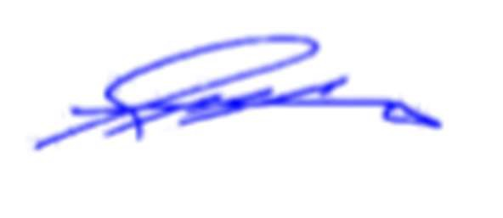SHAMS POWER COMPANY / General Manager Majed Al Awadhi

# ACKNOWLEDGEMENT

|  |  |  |  |  |
| --- | --- | --- | --- | --- |
|  | **Position** | **Name** | **Signature** | **Date** |
| **Written by** | Outage Planner | Ronald D’Souza |  | 13.8.2020 |
| **Checked by** | Maintenance Manager | Willem Nigrini |  | 13.8.2020 |
| Operation Manager | Akeel Ul Haq |  | 13.8.2020 |
| Quality Manager | Salem Al Mansoori |  | 13.8.2020 |
| Engineering Manager | Ali Al Masabai |  | 24.9.2020 |
| HSE  Manager | Abdulla Al Hammadi |  | 13.8.2020 |
| **Reviewed by** | Plant Manager | Abdulaziz Al Mheiri |  | 24.9.2020 |
| **Approved by** | General Manager | Majed Al Awadhi |  | 11.10.2020 |

**TABLE OF CONTENTS**

General Manager’s Message 2 Acknowledgement 4 General 8

Introduction 8

Brief Sequence of Key Events 8

Outage Highlights 8 Chapters 9

Chapter 1: Safety 1.1 Challenges

10

10

* 1. Measures applied by Shams 10
  2. Outcome

Chapter 2: COVID – 19 13 2.1 Challenges

11

13

* 1. Actions taken 13
  2. Outcome

Chapter 3: Steam turbine 15

14

3.1 General 15 3.2 Brief Scope of Works 21 3.3 Contractors Involved 22 3.4 Findings 22 3.5 Conclusion & Recommendations 24

**5**



Chapter 4: Generator 26

4.1 General 26 4.2 Brief Scope of Works 28 4.3 Contractors Involved 29 4.4 Findings 29 4.5 Conclusion & Recommendations 30

Chapter 5: Power Block 31

5.1 General 31



5.2 Valves 32 5.3 Pumps 36 5.4 Heat Exchangers 37

* 1. Tanks and Vessels 39
  2. Filters & Strainers 41 5.7 Main Transformer – 165 MVA 42 5.8 Unit Auxiliary Transformer – 25 MVA 44 5.9 Protection relays test for Generator, Transformer and MV / LV switchgear 45

5.10 UPS Batteries 46

5.11 Motors 46 5.12 Electrical Cables rectification works. 49 5.13 Instrumentation works. 49 5.14 Bolt tightening works. 52

Chapter 6: Solar Field 53

* 1. General 53
  2. Scope of Works. 53
  3. Contractors Involved 56 6.4 Findings 56 6.5 Recommendations 56

Chapter 7: Improvement Projects 57

7.1 Steam Turbine DCS upgrade 57 7.2 Air Cooled Condenser Cable modifications. 57 7.3 Booster Heaters 1 & 2 design and installation of walkway platforms. 59 7.4 Booster Heaters 1 & 2 burner modifications and commissioning. 60 7.5 HTF Heater – Alternative Communication Network Upgrade. 60 7.6 Steam Turbine Oil System Varnish removal unit. 61 7.7 Gas Reducing and Metering Station (GRMS) roof vents. 61 7.8 HTF Main pump area Overhead crane commissioning and load test 62 7.9 Steam Turbine Sprinkler System modification. 63 7.10 Main HTF pumps deluge and Steam turbine lube oil skid foam systems actual tests. 63

Chapter 8: Lessons Learnt 64

8.1 Documentation 64 8.2 Contingency Calculation 65 8.3 Outage Duration 65 8.4 Waste Management 65

Chapter 9: Outage Cost Analysis 66

* 1. Actual vs. Budget Overview 66 9.2 Reasons for Budget Over-run 67 9.3 Contingency / Extra Works. 68

Annexures 70

Annexure 1: MAN Steam Turbine findings report. 70 Annexure 2: Generator outage report. 70 Annexure 3: MAN Steam Turbine outage report. 70 Annexure 4: Power Block reports. 70 Annexure 5: Solar Field reports. 70 Annexure 6: Welding procedure for HP pipe. 70 Annexure 7: Ansaldo Energia HP Piping Support report. 70

# GENERAL

## Introduction

As per the O&M plan, the first major outage scheduled in Year 7 (2020) features the major overhaul of the steam turbine and generator. Due to the prolonged outage duration, all other maintenance activities that require a plant shutdown and time greater than that of a minor outage were considered.

The initial plan drafted for 24 days took into account that the Steam Turbine activities are critical path and there would be no major repair activities other than the rotor replacement. However, the actual situation of the outage did not reflect the same.

The major outage on Shams 1 power plant was executed successfully and safely from 1st March until 4th April 2020 (35 days).

## Brief Sequence of Key Events

29th February 2020: Last commercial operation. 1st March 2020: Outage commencement.

4th March 2020: Steam Turbine Turning Gear stopped. 7th March 2020: Entire HTF system draining completed.

17th March 2020: Extension of the outage due to clearance issues on the Steam Turbine. 24th March 2020: MAN Germany team leave UAE and MAN Dubai team arrive onsite. 31st March 2020: Turning gear incident during commissioning.

4th April 2020: Steam Turbine commissioning completed and hand over to operations.

## Outage Highlights

1) 0 LTI / MTC / RWC.

* + 1. 204,249 man-hours liquidated.
    2. 488 personnel worked onsite.
    3. 25 contractors managed by Shams team.
    4. 838 welding joints implemented in the Solar Field.

## Chapters

This report divided into five sections as shown below. Chapter 1: Safety

Chapter 2: COVID - 19 Chapter 3: Steam Turbine Chapter 4: Generator Chapter 5: Power Block Chapter 6: Solar Field Chapter 7: Projects Chapter 8: Lessons Learnt Annexures

Note: All detailed technical reports are available on request.

# CHAPTER 1: SAFETY

## Challenges

To implement the planned outage scope in March over 450 personnel were involved. This meant that there was increase potential of incidents and accidents onsite. The challenge was to educate and enforce Shams safety rules 24 hours in order to prevent Lost Time Incidents.

Other challenges included:

* + 1. PTW review and Risk assessment of more than 436 Work Orders without any delay.
    2. High Risk potential hazards.
       1. HTF – Fire Hazard.
       2. High number of heavy lifts.
       3. Use of make shift tools which are not certified.
       4. Two shifts in all areas of plant.
       5. Management of Co-activities.
    3. Risk of Infections due to COVID – 19.

## Measures applied by Shams

In order to cover and mitigate all potential hazards and risks the following measures were taken before, during and after outage.

1. Safety induction meeting prior to outage.
2. Contractors gatherings and toolbox talks (See Fig. 1)
3. PTW / LOTO trainings for contractor’s supervisors.
4. Rescue training for outsourced safety officers.
5. Site PTW audits and safety requirements compliance reviews.
6. Introduction between contractors and Shams supervisors. (See Fig. 2)
7. Detailed planning to ensure everyone knew what to do on the first day and every day after.
8. Shams inspections to ensure correct tools and equipment used during the outage.
9. Shams inspections to ensure all cranes and lifting equipment certified.
10. Review, approval and supervision of all lifting operations.
11. Performed serval safety walk downs daily.
12. Daily reporting on potential safety hazards during outage meeting.
13. Implement Pre Start-up Safety Review and Box-up certificates.
14. COVID 19 checks and precautionary measures.
15. Contractor’s locations layout prepared based on project scope prior to outage.
16. Distribution of spill de-contamination materials to work areas.
17. Ensuring supervision of critical activities (confined spaces…)
18. Ensuring daily site clean-up and shifting of all generated waste to waste area.

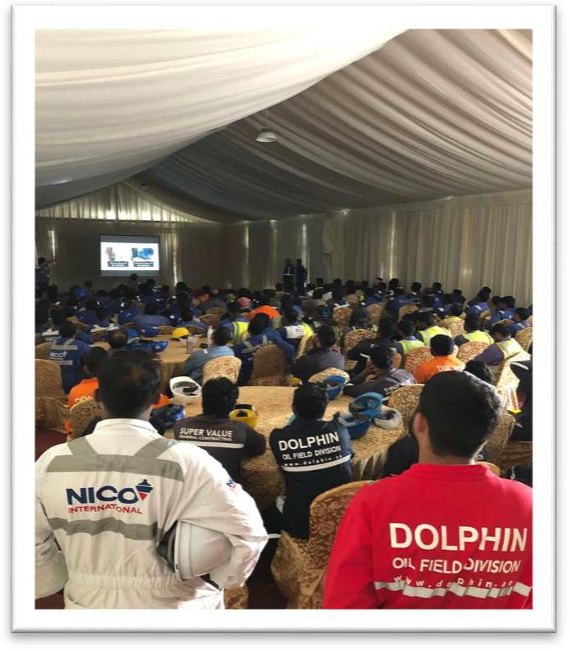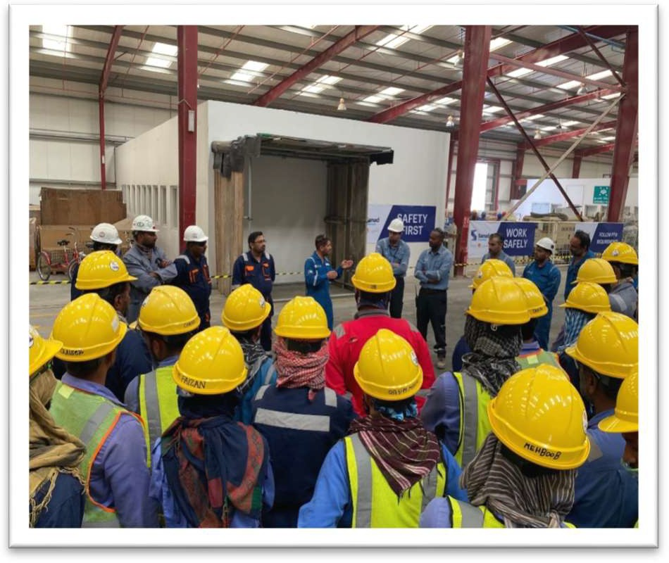

Figure 1: Safety induction meeting prior to outage. Figure 2: Introduction between contractors and Shams.

## Outcome

The outage spanned a total of 35 days and had plethora of activities happening at the same time. With the above measure taken, the following were the outcome.

* + 1. Zero LTI / MTC / RWC.
    2. Draining of 600 Tons of HTF by Operations without any spills.
    3. Isolated and draining HTF system 2 days ahead of schedule.
    4. Issued Permits to work daily without any delays.
    5. Zero known COVID – 19 infections.
    6. Three First Aid cases.
    7. One HTF spill recorded during outage period.

# CHAPTER 2: COVID – 19

## Challenges

The economic and logistics effects of the COVID - 19 pandemic had influenced Shams during the outage like never before. The following were the challenges Shams faced.

* + 1. Dealing with technical findings extended the outage by 7 days. (24th March to 31st March)
       1. Travel restrictions complicated the technical issues that required external party specialty workshops to aid in repairs.
    2. OEM specialists from MAN & BRUSH left site on 23rd and 24th March respectively.
    3. New MAN team from Dubai arrived on 24th March at 1pm, to assemble and commission the machine.
    4. There was no handover or any form of information shared between the MAN Germany team and MAN Dubai team. The lack of handover was detrimental because MAN never submitted sufficient documentation prior to the outage e.g. drawings, procedures and protocols.
    5. The Lead engineer from MAN Germany removed from the project at soon as he left site. No support from the MAN person who was aware of the complete technical situation at the time.
    6. MAN DCS team was inexperienced and not confident at all. This resulted in the turning gear incident.

## Actions taken

Shams updated MAN team from Dubai on the status of the outage with all the technical issues that were faced as well as repairs that were currently on-going at the time.

Since there was disconnection between the MAN Germany team and the MAN Dubai team, Shams became the critical link to ensure information passed on in order to proceed with the outage activities.

Shams prepared protocol sheets for the loop, function checks, and shared with MAN DCS Dubai team in order to progress further. This crucial step enable Shams to avoid further delays on an already extended outage.

Shams re planned repair activities and shuffled personnel such that the new travel restrictions due to COVID – 19 implemented in the country which minimal impact on the outage.

## Outcome

This was an exceptional challenge and despite the impact of COVID 19 and OEM specialists leaving site, Shams managed to complete the outage.

Successful commissioning of the Steam Turbine with inexperienced DCS team and insufficient OEM documents or procedures.

Performed the Steam Turbine Over-speed test successfully.

***Antonio.Antonuccio***

*2021-02-11 11:11:07*

--------------------------------------------

Indication that there was a discrepancy between what they were expecting/planning to do based on available info and the actual work they had to perform

# CHAPTER 3: STEAM TURBINE

## General

Shams employed a strategy where in the execution of the major outage on the steam turbine would be divided into two main contractors working under Shams.

* + 1. The OEM supervision: MAN Energy Solutions.
    2. Third party execution labor force: Turbine Services & Solutions (Sanad Powertech) with their main subcontractor Ansaldo Energia.

The OEM supervision team would be responsible for directing the task of the major outage, take all readings and measurements as per protocol, identify and recommend solutions to all technical findings, lead with commissioning activities until the Steam Turbine was functional as per operating parameters and A final outage report submitted to Shams.

The Third party support team would be responsible implementation of the planned & unplanned activities provide all the required certified tools, lifting equipment, experienced labor, scaffolding & insulation services, office cabins, etc.

Additional contractors were also involved based on the technical finding repairs required during outage, as shown below.

1. EM Hydromontaza – HP pipe cutting, welding, and pipe supports inspection and repairs.
2. Petro Engineering Power Services – Honing of coupling bolts.
3. Rainbow Mechanical Solutions – Machining of Steam Turbine components.
4. CAPE East LLC – Steam Turbine Re-Insulation.

The initial plan drafted was for 24 days and took into account that there would be no major repair activities other than the rotor replacement. However, the actual situation of the outage

was very different.

The steam turbine outage divided into four phases: Dismantling phase, Inspection phase, Re- assembly phase and Commissioning phase.

***Antonio.Antonuccio***

*2021-02-11 11:12:23*

--------------------------------------------

Again they missed a key piece of information about one of the most critical components - this should have been clearly visible in the original drawing or in the commissioning reports

Dismantling Phase

During the dismantling phase we identified the inlet HP pipe (material: P91) was not flanged  but welded and had to cut in order to remove the massive top steam turbine outer casing. Fig.

3 shows lifting of the top outer casing.

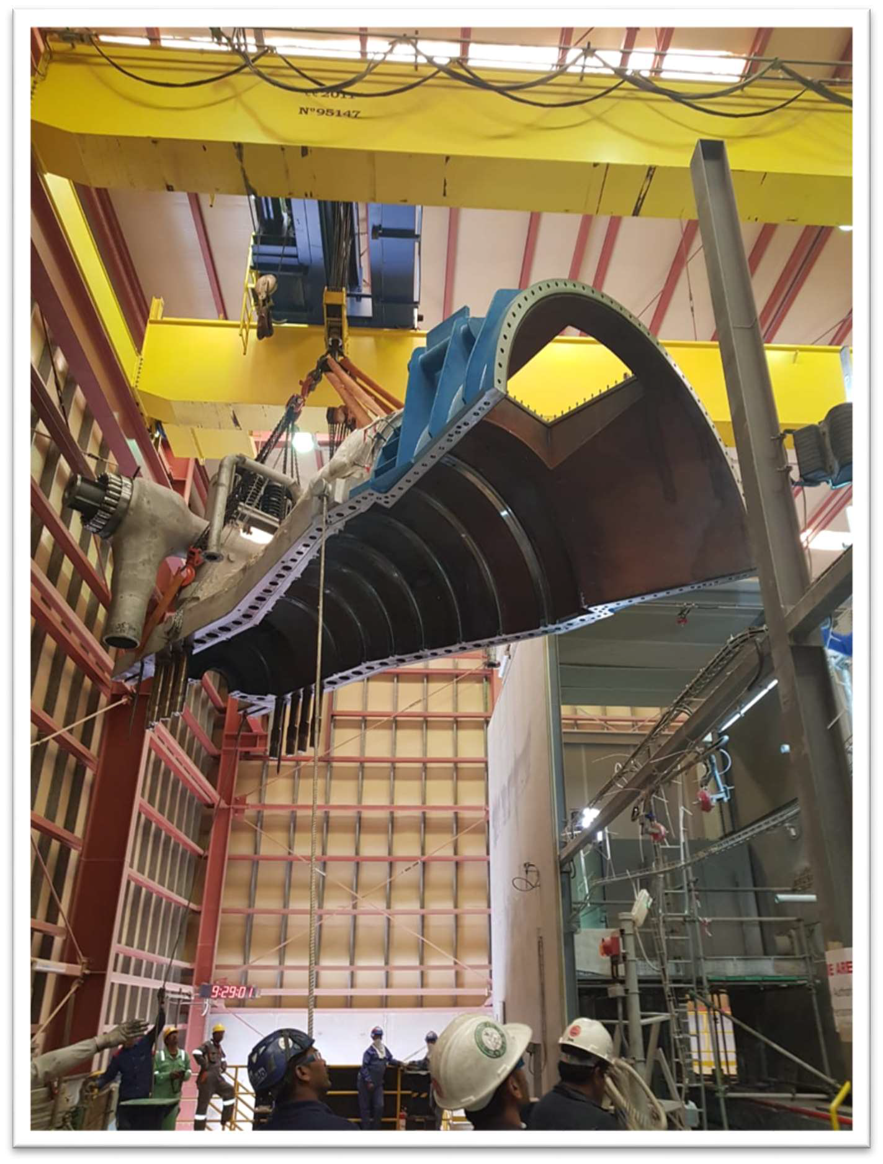

Figure 3: The lifting of the steam turbine top outer casing.

The P91 pipe was cut 20 cm above the heat affected zone from the previous weld as shown in Fig. 3.1. A pneumatic profile cutter was used to cut the pipe with the specified welding beveling profile, as shown in Fig. 3.2.

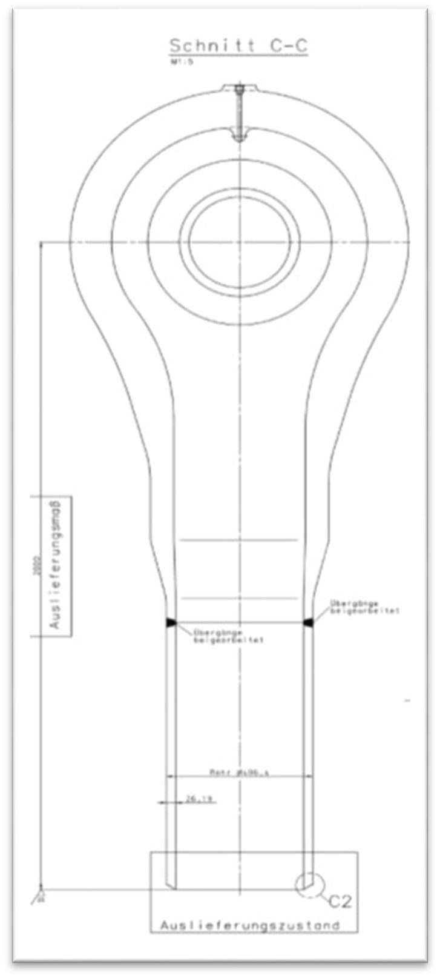

HP header connection to the Steam Turbine Technical specification:

* + HP Header material – P91
  + ST Nozzle material – P91
  + Pipe external Diameter – 406.4mm
  + Pipe wall thickness – 26.19mm
  + HP below header material – P22

Figure 3.1: Marking point of the pipe cutting on the HP pipe inlet.

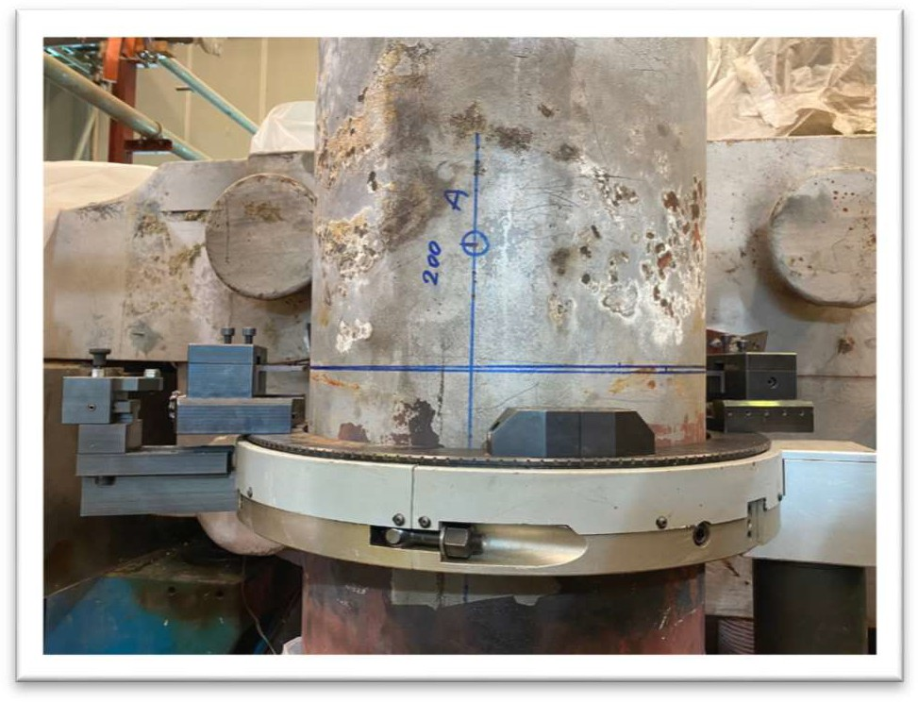Figure 3.2: Pipe cutting on the HP pipe inlet.

***Antonio.Antonuccio***

*2021-02-11 11:33:12*

--------------------------------------------

Lack of information on the shape and size of the asset led to 7 days extension

Safety Note: The overhead crane vertical limits had to be adjusted in order to remove the rotor and was return to original setting after commissioning.

Inspection / Technical finding Phase

Towards the end of the inspection phase when the final clearance measurements taken with the new rotor installed we soon realized that the clearance were too small and therefore many

of the steam turbine stator components had to be machined in specialized machine workshops

in Abu Dhabi & Dubai. These findings resulted in a 7 days extension of the outage (Ref. Annexure 1 for detailed findings report).

***Antonio.Antonuccio***

*2021-02-11 11:34:03*

--------------------------------------------

indication of lack of proper parts inventory?

***Antonio.Antonuccio***

*2021-02-11 11:34:56*

--------------------------------------------

Asset Integrity Issue with HP Piping support, which were the causes? weldings involved?

***Antonio.Antonuccio***

*2021-02-11 11:37:01*

--------------------------------------------

Why they identified this issue only during the installation of the new rotor rather than before? there wasn't a way to compare they size of the bolt holes with the size of the screws?

Even though we ordered the recommended spares from the OEM, many spares such as the

balance pistons, inner casing horizontal bolts, connection pins between turbine and casing had

to be fabricated from raw materials X22 e.g. shown in Fig. 4.

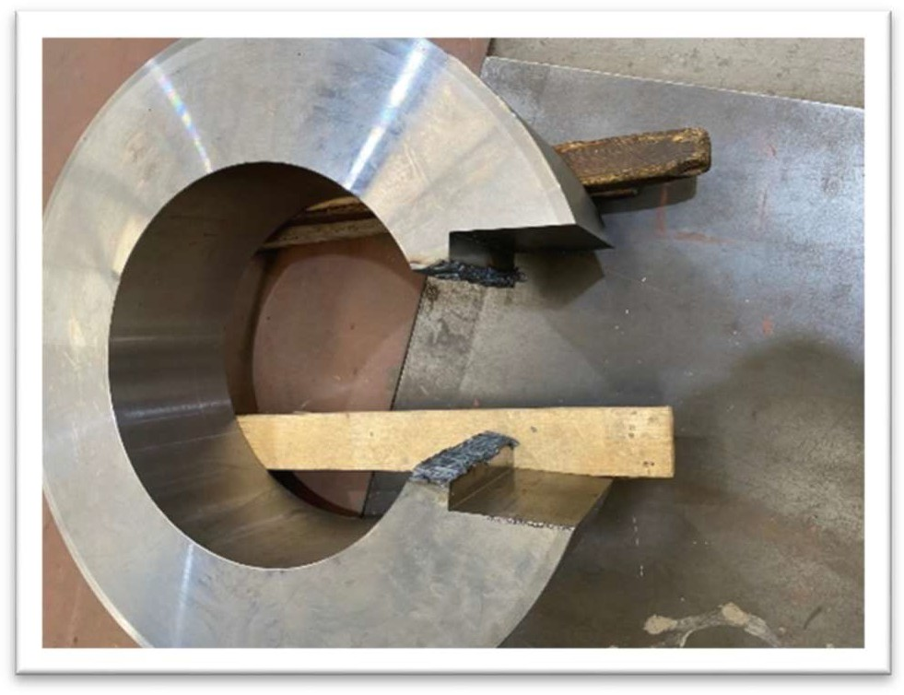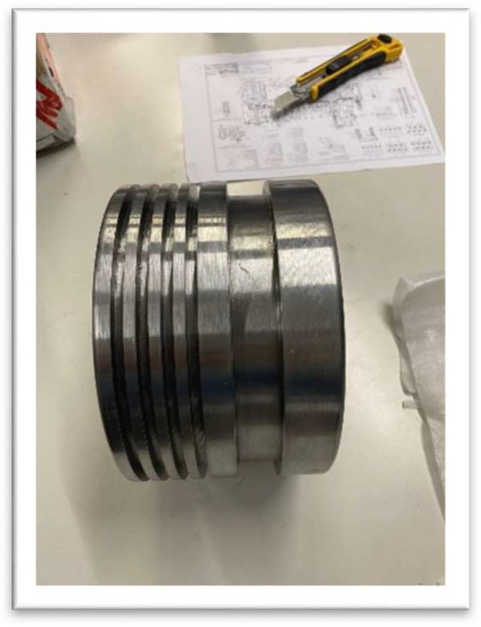

Figure 4: showing apiece cut out & fabricated into spare part indicated by the arrow.

We also identified the HP piping support were damaged and deformed in many locations. Shams then assigned Ansaldo Energia who specialize in this area to survey (Ref. Annexure 7 for detailed Ansaldo report) and rectify these issues. The HP header was elevated to ensure no stress induced on the Steam Turbine casing.

COVID-19

On 23rd March 2020, MAN supervision & DCS team from Germany who had been working onsite since the commencement of the outage, decided to leave site following the instructions from their Germany head office due to the COVID – 19 pandemic. The new MAN team from Dubai arrived the next day in the afternoon and were clueless as there were no handover information passed from the Germany MAN team. Shams had to orient and bring them up to speed with the latest, which was challenging because no viable documents shared by the OEM (MAN Energy Solutions).

Reassembly Phase

During the reassembly phase, we identified that the new rotor coupling bolt holes were

undersized and honing was required. A preliminary contractor (recommended by OEM) brought to ream the holes however; they were stopped by Shams following the damage on the first hole

***Antonio.Antonuccio***

*2021-02-11 11:40:50*

--------------------------------------------

AI-driven technology can be applied to deliver a higher quality inspection and reporting

due to poor workmanship. Later, during the reassembly phase another time slot was identified and this time a specialized company Petro Engineering Power Services (PEPS) was brought and completed the job perfectly.

After the top outer casing were finally installed, the P91 HP steam header was re-welded to the upper casing (Ref. to annexure 6 for the detailed welding procedure). Post weld heat treatment was then applied and allowed to cool down naturally until final radiography (Non Destructive

Testing) was taken and revealed positive results.

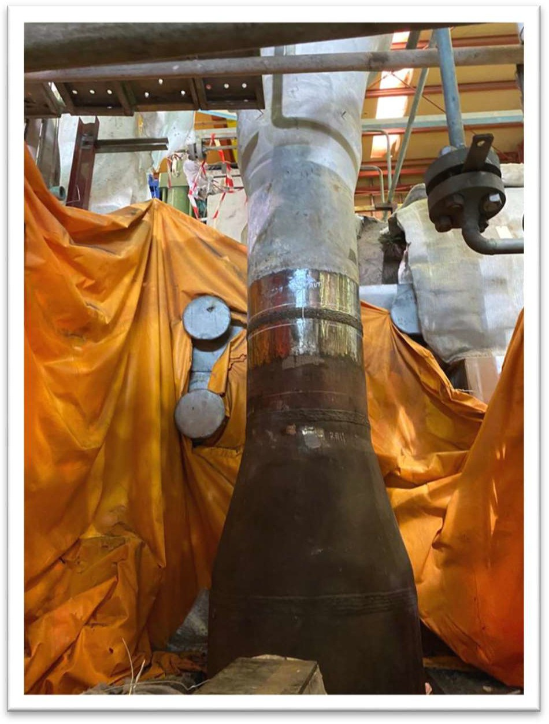Please see Fig 4.1.

Figure 4.1: Welding, PWHT and final testing of HP pipe.

During the welding of the HP pipe 8 dial gauges installed around the steam turbine to monitor the slightest movement that may result from the welding of the inlet HP pipe. There was no movement identified.

Commissioning Phase

The commissioning phase had to be coordinated between the Dubai MAN Supervision and DCS team. During this time, the Dubai MAN DCS team were struggling to complete the various

logic and protection tests, moreover on the Steam Turbine the new governor valve actuator had issues (details on Annexure 3). In order to continue with other activities it was discussed and agreed with the Dubai MAN DCS team to continue stroking the Governor valve keeping the Stop valve or Trip valve closed while the HP steam line were warmed up with live steam. At the point of execution due to simulation errors, the stop valve opened leading to live steam entering the Steam Turbine while the new turning gear was engaged, the speed reached up to 320 rpm before the stop valve was closed and this lead to the turning gear incident.

The new turning gear was inspected after the incident and found the gear wheel on the new rotor was damage (we had one spare available) as well as the new turning gear had to be replaced with the old one. After these components replaced, the Steam Turbine was successfully commissioned along with the physical Overspeed test (please see Fig 4.2 and ref. Annexure 3 for detailed MAN report, page 130) and handed over back to operation on 4th April 2020.

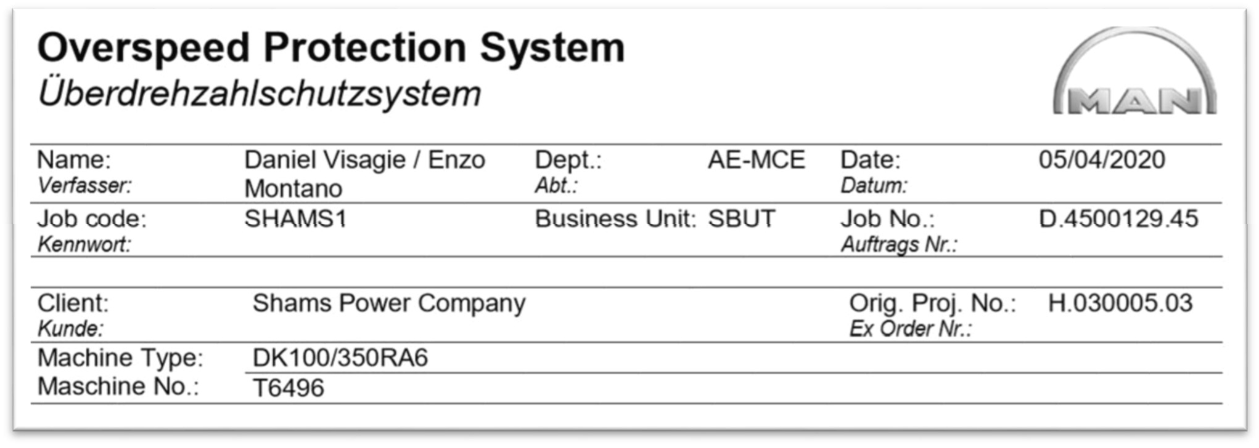

Figure 4.2: Overspeed Protocol – Ref. Annexure 3.

***Antonio.Antonuccio***

*2021-02-11 11:44:33*

--------------------------------------------

What were the key info/data that had to be gathered to perform these works? Were they all available? In digital form? Easy to consult and use?

***Antonio.Antonuccio***

*2021-02-11 11:45:17*

--------------------------------------------

What were the key info/data that had to be gathered to perform these works? Were they all available? In digital form? Easy to consult and use?

## Brief Scope of Works

The following scope of works carried out during the major outage. 

* + 1. Steam Turbine
       1. Complete Dismantling of the Steam Turbine.
       2. Removal of old rotor.
       3. Inspection of all parts and components such as bearings, static blades, carriers, seals, etc. including instrumentations.
       4. Replacements / repairs of parts as per findings.
       5. Lube oil tank inspection, Oil treatment and flushing.
       6. Lube oil coolers inspection and maintenance.
       7. Oil system filters replacement.
       8. Installation of new rotor.
       9. Installation of parts, components along with clearance checks.
       10. Machining and adjustments of Steam turbine components followed by final clearances.
       11. Install turning gear.
       12. Alignment & Coupling of Steam Turbine and Generator rotors.
       13. Final Commissioning.

* + 1. HP Pipe & pipe support rectification (finding during outage)

a. 

Inspection and analysis of HP pipes and Pipe Supports.

1. Re-adjustment of pipe supports in cold condition.
2. Final adjustment of supports during hot conditions.
3. Monitoring of supports.

* + 1. Instrumentations
       1. Disconnection, inspection and reconnection of instrumentation.
       2. Calibration of all Steam Turbine and Generator Instrumentations.
       3. Perform stroke test of Emergency stop valve, Governor Valve and Bleed valves.

***Antonio.Antonuccio***

*2021-02-11 11:47:33*

--------------------------------------------

Could these issues have been prevented by having better info and data?

## Contractors Involved

The following are the main contractors assigned by Shams.

* + 1. MAN Energy Solutions
    2. Turbine Services and Solutions (Sanad)
    3. Ansaldo Energia
    4. Petro Engineering Power Services
    5. CAPE East LLC
    6. Rainbow Mechanical Solutions LLC

## Findings

The following are the main critical findings related the Steam Turbine.

1) 

Bearing housing no. 1 shims deformed from initial position.

1. Journal bearing scotch marks observed due to foreign material in lube oil.
2. Inadequate clearances on the blade carriers and balance piston. Machining carried out at specialist workshops (Fig. 5 & 6)

4)

Undersized coupling bolt holes of the new rotor.

1. New governor valve actuator was not functional.
2. Turning gear incident damaged Turning gear and Rotor gear wheel. New gear wheel installed (Fig. 7 & 8) and old turning gear reused.
3. Instrumentation cables found burnt and replaced with high temperature resistant materials.
4. Foreign material found inside the lube oil tank. The Lube oil tank cleaned and refilled.
5. Minor traces of varnish found inside the tank indicated by the level mark. The oil heater also covered with varnish particles.

Ref. Annexure 1 & 4e for detailed reports.

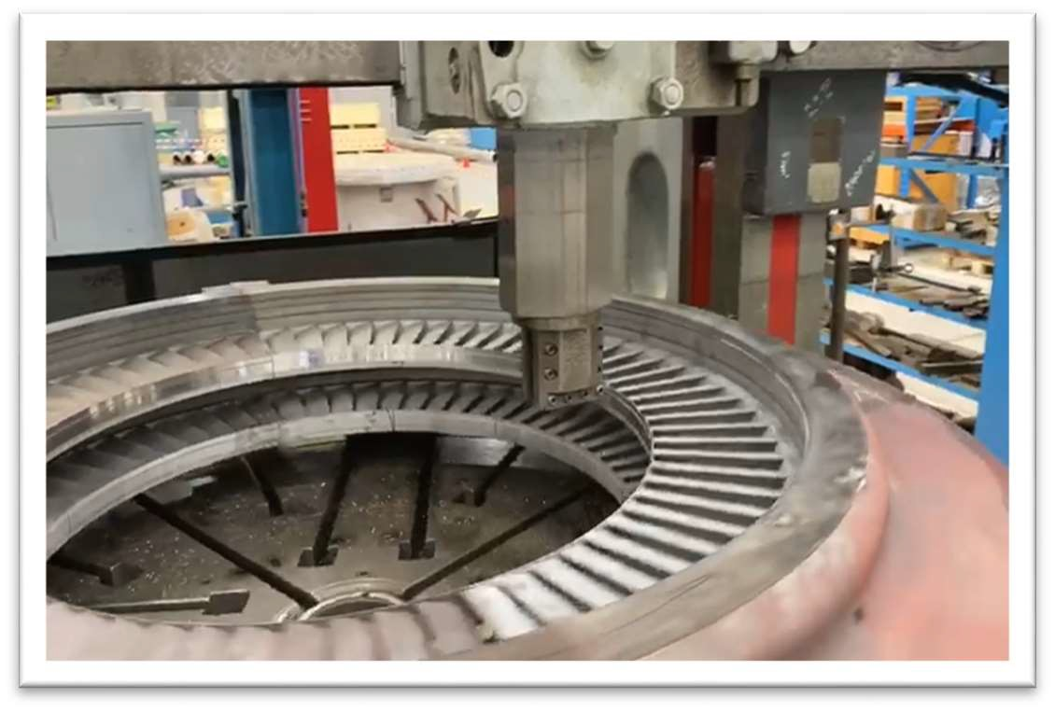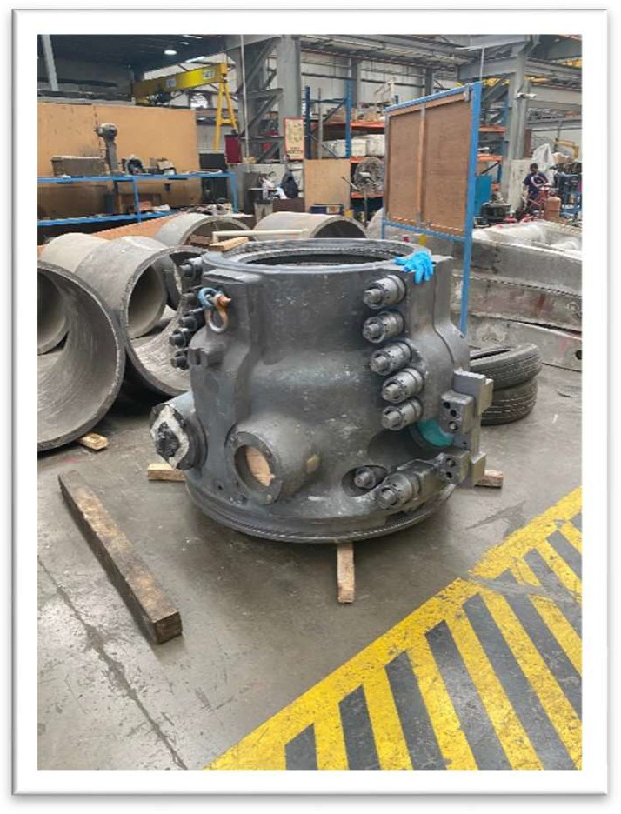

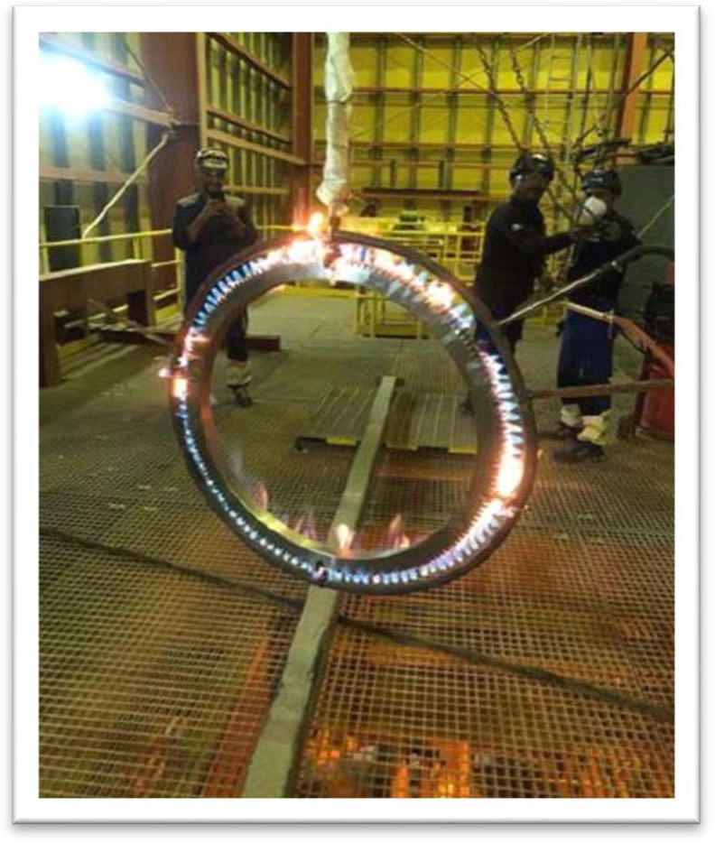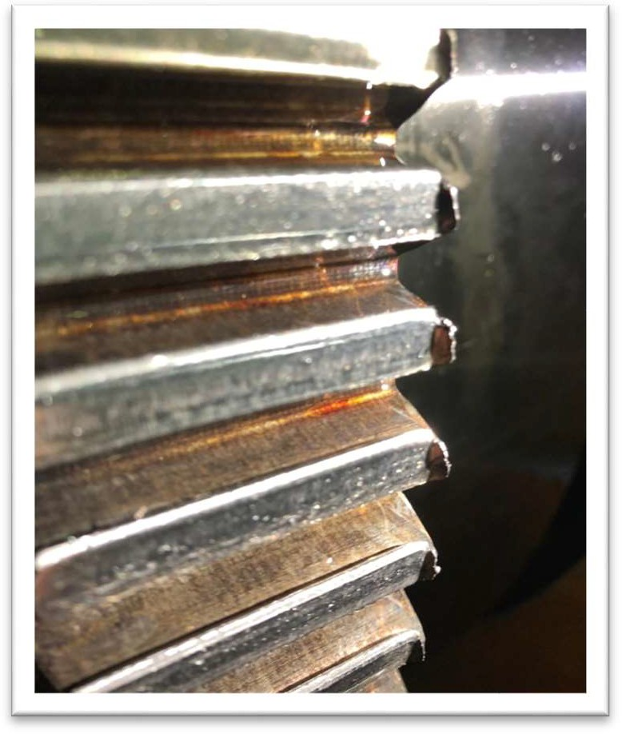Figure 5: Machining of blade carriers. Figure 6: Machining of balance piston

Figure 7: New Gear ring heating for installation as

per procedure.

Figure 8: Damage Gear wheel seen on the corners.

1. HP Header and Supports.
   1. Stress impact of HP Pipe on the ST casing and Front Bearing Housing. (Fig. 9)

b. HP header supports found damaged, deformed and installed incorrectly.

(Fig. 10)

c.

Lower part of the HP pipe to the top casing material was found different

compared to drawing 4545-PLN-AGI-25-65-0004-R1LBA10_sht_6_Rev14

(found material P22 instead of P91)

Ref. Annexure 7 for detailed Ansaldo report.

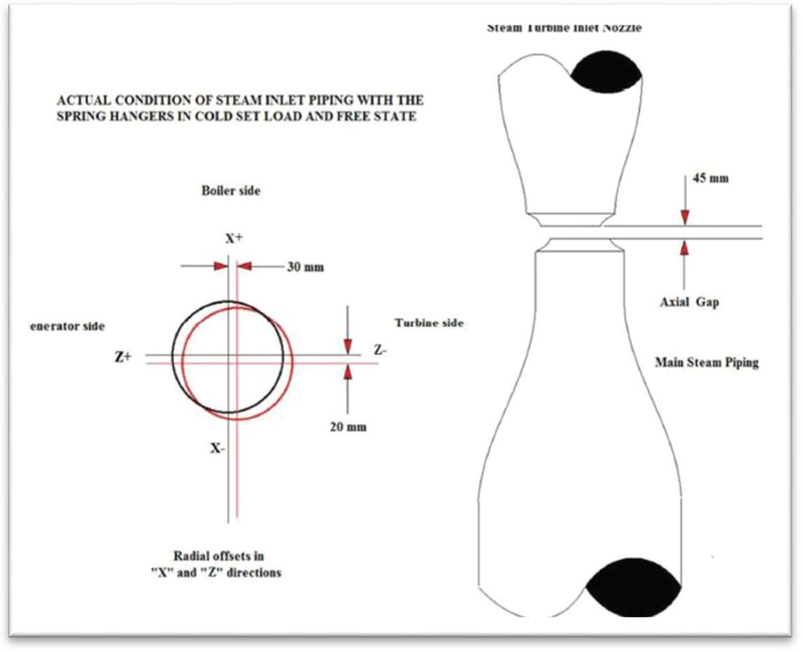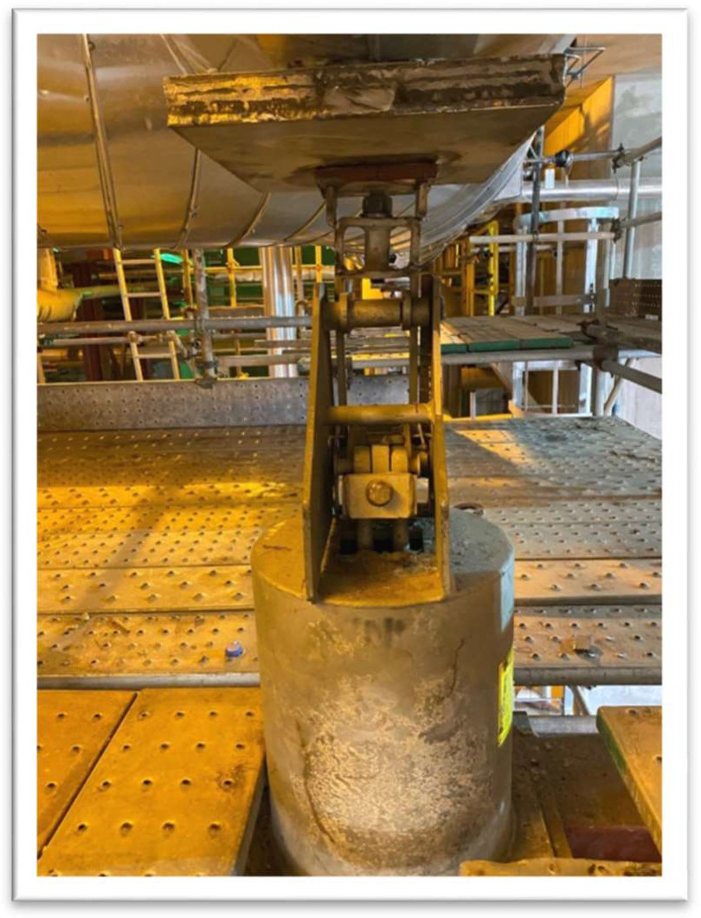

Figure 9: Diagram showing displacement of the HP pipe to the casing inlet pipe.

Figure 10: HP Header support damage.

***Antonio.Antonuccio***

*2021-02-11 11:49:27*

--------------------------------------------

Mismatch of info/data between drawings/specs and actual part - which info was collected on the installed component?

***Antonio.Antonuccio***

*2021-02-11 11:51:14*

--------------------------------------------

Potential issue in collecting info from OEM due to IP rights. How can be overcome?

## Conclusion & Recommendations

The execution of the major outage on the Steam Turbine was the critical path and took 35 days to complete successfully. The Steam Turbine is cleared by MAN (OEM) to operate for next 7 years.

 This

MAN supplied the minimum technical documentation due to intellectual property rights.

created problems with the ordering of spare parts and monitoring of the outage.

In addition MAN provided a poor findings and outage reports. Shams is still in the process of negotiating with the OEM to obtain detailed technical documentation and a more comprehensive report.

***Antonio.Antonuccio***

*2021-02-11 11:52:18*

--------------------------------------------

How can the maintenance strategy be enhanced through availability/access to better asset integrity info?

***Antonio.Antonuccio***

*2021-02-11 11:52:33*

--------------------------------------------

Akselos?

***Antonio.Antonuccio***

*2021-02-11 11:53:39*

--------------------------------------------

Clearly some key documentation was missing as they wanted to make it compulsory for the OEM to provide it.

***Antonio.Antonuccio***

*2021-02-11 11:54:39*

--------------------------------------------

use of Ai2 solution might be recommended as part of NDT process for the next scheduled outage

The following are the recommendations related the Steam Turbine.

1. Review list of spares to be refurbished and keep ready for next major outage.
2. Order required spares in time for the next major outage.
3. ST Vibration and Speed pick up sensors must be replaced in the next major outage, as per MAN recommendations. Please note, the gap and direction check of the speed pickup sensors should be checked before closing the NDE bearing.
4. Upper and lower casing instruments must be replaced in the next major outage.

e. Review existing maintenance strategy for future Steam Turbine inspections.

f. Monitor the movement of the main steam header and bearing no.1 casing.

1. Define the commissioning procedures for the lube oil and turning gear with the OEM.
2. The Overspeed test was successfully completed and should be done during the next major outage.



i.

The required documentation must be specified in the RFQ and contract before

the next major outage.

1. Special tools to be inspected and verified 1 year prior to the major outage.
2. All spare parts to be verified with the OEM 1 year prior to the major outage.
3. Arrange machining contracts with workshops in Abu Dhabi and Dubai prior to the major outage.
4. Arrange adequate raw special materials to manufacture ST components in case of findings (X22 material).

n.

in the detailed outage schedule

Cutting, welding, heat treatment and NDT of the HP header should be included

1. The HP header should be blocked with a special tool to prevent it from moving before cutting
2. Cutting of the HP header should be done with a pneumatic profile cutter to save time and to prevent the magnetism of the HP header.
3. The HP header should be checked for cleanliness before final installation of the steam turbine upper casing.
4. Lube oil coolers overhauling must be implemented every major outage.

Ref. Annexure 1, 3 & 4e for detailed reports.

# CHAPTER 4: GENERATOR

## General

The initial scope for the generator was a minor inspection, however there were issues identified with the generator in these areas as shown below (please refer annexure 2a for more details).

1)

Drive End and Non Drive End bearing Vibrations.

1. Generator unbalanced current alarms.
2. Generator Stator Winding temperature.

Due to the above mentioned points and considering the maintenance intervals Shams decided to change the scope from Minor inspection to Major inspection. This required the OEM specialist BRUSH UK to perform the supervision and therefore the scope was divided between two main contractors.

1. The OEM supervision & inspection: BRUSH UK.
2. Third party execution labor force: Turbine Services & Solution with their main subcontractor Ansaldo Energia.

The OEM supervision & inspection team would be responsible for directing the task of the major outage, take all readings and measurements as per protocol, carry out all electrical tests, identify and recommend solutions to all technical findings, commission the generator as per operating parameters and a final outage report submitted to Shams.

The Third party support team would be responsible for supplying experienced labor, provide all the required certified tools, lifting equipment, scaffolding & insulation services, etc.

An additional contractor, Osbourne Engineering Services was involved for the refurbishment of one generator bearing during the outage.

The plan drafted was for 18 days with the outage divided into four phases: Dismantling phase, Inspection & testing phase, Re-assembly phase and commissioning phase.

Dismantling Phase

The generator dismantling commenced with the removal of mechanical, electrical and instrumentation connections following by the removal of the generator rotating diodes, the generator excitation system, generator end covers, and top & bottom bearings.

An additional scaffolding platform and a special certified tool called the Turfer were essential to pull out the generator rotor onto a railing with the support of wooden cradle (please see Fig. 11) for inspection and testing.

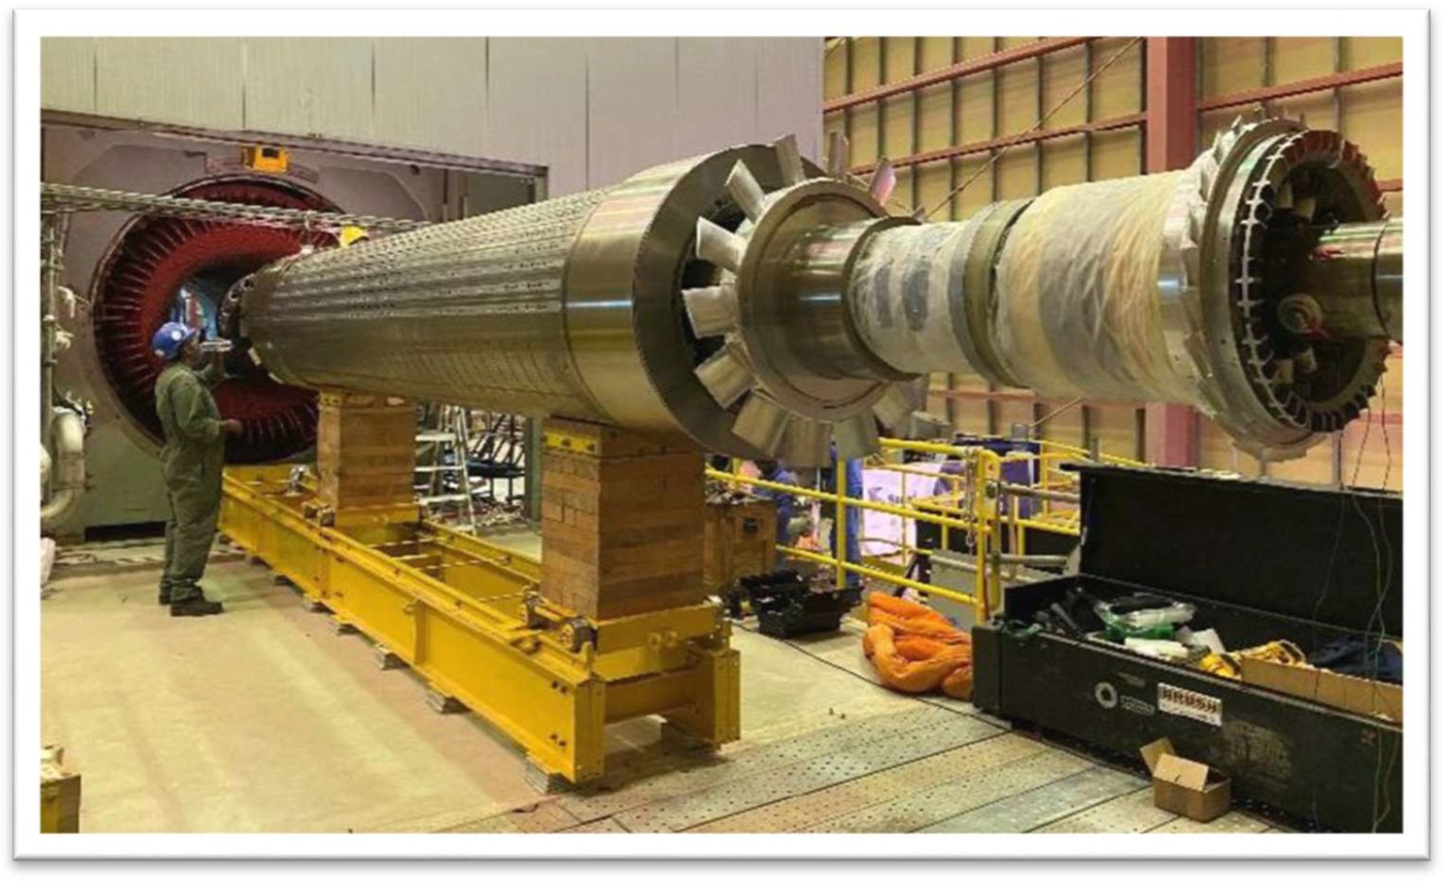

Figure 11: Generator rotor slide out for inspection and testing.

Inspection & Testing Phase

During the inspection phase, both the DE and NDE bearings were found with light scoring marks, the NDE was replaced with spare and the DE bearing was installed after its refurbishment. Also, the rotor inter-slot wedges showed signs of migration, they were re-peened into position.

Ref. Annexure 2b for detailed Brush report.

The following electrical tests were carried out on the rotor and stator.

* 1. Insulation Resistance tests.
  2. Stator core test.
  3. Electromagnetic Core Imperfection Detection test (ELCID).
  4. Rotor core and winding tests.
  5. Generator protection tests.
  6. Wedge tap test.
  7. Repetitive Surge Oscillation test.
  8. Rotor Earth fault test.

All electrical tests results showed nominal. Kindly ref. Annexure 2b for detailed Brush report.

Reassembly Phase

During the reassembly phase the rotor was pulled back into position through the generator stator following the installation of the drive and non-drive end bearings, generator end covers, excitation systems, generator rotating diodes and all electrical, instrumentation and mechanical connections. All mechanical works on the generator were completed once the generator rotor was ready for coupling and alignment with the steam turbine rotor.

COVID-19

Throughout the generator outage phases there were not major concerns, however due to the COVID – 19 international travel restrictions Shams requested the BRUSH commissioning engineer to come to site earlier than planned (20th March). Unfortunately, the outage extended due to the findings on the Steam turbine mentioned in Chapter 3. On 4th April 2020, Brush personnel left site without completing the AVR firmware update due to the travel restriction in the UAE (repatriation flight to UK) and therefore this task was not completed. However, the fact that the AVR firmware were not updated has no impact on the availability and reliability of the Generator. It will be implemented at the next opportunity.

## Brief Scope of Works

The following scope of works carried out during the major outage.

1. Complete Dismantling of the generator end covers.
2. Sliding out of generator rotor.
3. Inspection of stator and rotor components and parts.
4. Inspection of mechanical parts such as bearings, fans blades, etc.
5. Inspection of generator circuit breaker, control panel and voltage transformers.
6. Inspection of generator neutral earthing system.
7. Generator cooler leak test.
8. Electrical tests for the rotor and stator.
   1. Insulation Resistance tests.
   2. Stator core test.
   3. Electromagnetic Core Imperfection Detection test (ELCID).
   4. Rotor core and winding tests.
   5. Generator protection tests.
   6. Wedge tap test.
   7. Repetitive Surge Oscillation test.
   8. Rotor Earth fault test.
9. Replacements / repairs of parts as per findings. 11)Installation of generator rotor.

12)Box up of Generator components and parts. 13)Instrumentation checks in coordination with Steam Turbine.

## Contractors Involved

The following are the main contractors assigned by Shams.

* + 1. BRUSH UK
    2. Turbine Services and Solutions (Sanad)
    3. Ansaldo Energia
    4. Osborne Engineering Services

## Findings

The following are the main critical findings related the Generator.

* + 1. Slight scoring marks on both Drive and Non Drive end Bearings.
    2. Generator Rotor Journals had light scoring marks.
    3. Generator rotor inter-slot wedges showed signs of migration, they were re-peened into position.

***Antonio.Antonuccio***

*2021-02-11 12:01:06*

--------------------------------------------

Avoidable with better asset integrity info?

* + 1. Generator cooling water leak on the cooler end plates. Gaskets replaced.
    2. Reverse power protection and unbalanced current protection tested by Secondary Injection and protection relays operated as expected.
    3. AVR firmware not updated to the latest version due to COVID – 19.

7) Incorrect bearing supplied by OEM resulted in a persistent oil leak on the NDE bearing.

8) Incorrect jacking oil hoses were supplied and had to be replaced as an emergency.

Ref. Annexure 2 & 4 g for detailed report.

## Conclusion & Recommendations

The execution of the major outage on the Generator was completed except for the AVR firmware update and testing due to the COVID – 19 situation.

The electrical test on the generator rotor and stator windings showed that the generator is in good condition and can run until the next major inspection. The vibration issues were attended by replacing the bearings. The winding temperature issues rectified during the outage. The Generator was cleared by BRUSH (OEM) to operate safely until next major outage.

The following are the recommendations related to the Generator.

1. Update AVR firmware to the latest version at the next opportunity.
2. Generator Major Inspection must be linked with Steam Turbine Major Inspection.
3. Generator jacking oil hoses must be replaced 2 yearly.
4. Electrical tests as specified in the OEM outage report and by the OEM should be done in the next major outage.
5. Install an online PD measurement equipment during the next major outage.
6. All spare parts to be verified with the OEM 1 year prior to the major outage.
7. Special tools to be inspected and verified 1 year prior to the major outage.
8. Generator internal cleaning must be carried out in the next major outage.
9. Generator vibration sensors and winding thermocouples must be replaced in the next major outage, as per MAN recommendations. Please note, the gap of the vibration sensors should be checked.

Ref. Annexure 2 b for detailed reports from BRUSH.

# CHAPTER 5: POWER BLOCK

## General

The major outage on the steam turbine required all other equipment in the power block to be offline and isolated, therefore all other maintenance activities on the power block that require a plant shutdown and time greater than that of a minor outage were considered.

The Power Block consist of the all auxiliary equipment such as Booster Heaters systems, Solar Steam Generators systems, Feed-water systems, Gas & Oil systems, Valves, Pumps, Motors, Transformers, Switchgears, Instrumentations, etc.

The maintenance activities divided into three in terms of services as shown below.

* + 1. In house: Maintenance activities implemented by Shams teams.
    2. Outsourced: Maintenance activities implemented by contractor teams.
    3. Support services: These activities were scaffolding, inspection, insulation, crane & labor supply.

The strategy was to allocate one or two main contractors as a lump sum contract to implement all outsourced maintenance activates as specified in the scope of works. Two companies were identified as shown below.

1. NICO international: Responsible for all the valves, pumps, motors & heat exchangers maintenance activities.
2. Turbine Services and Solutions. Responsible for the all-electrical equipment such as the transformers, switchgears, battery chargers, batteries, etc. maintenance activities.

Support services such as scaffolding, insulation, mobile cranes and labor supply were required during various maintenance activities. Below are the contractor involved.

1. National Protection and Painting Company - Scaffolding & Insulation services.
2. Al Faris – Mobile crane services.
3. International Inspection Services.
4. NICO international – Labor supply.

## Valves

* + 1. The following valves considered with their brief scope of works.
       1. Pressure Safety Valves (PSVs) X 81. Please see Table A.
          1. Removal of PSVs.
          2. Bench test of PSVs.
          3. Refurbishment of PSVs based on bench test results.
          4. Re-Installation of PSVs.

Table A: KKS numbers.

|  |  |  |  |
| --- | --- | --- | --- |
| 01MAV16AA810 | R1EKD10AA201 | R1EKD10AA202 | R1CIA11AA201 |
| R1EKD11AA201 | 01MAX12AA810 | 01MAX11AA810 | R1EKD12AA201 |
| R1EKD31AA201 | R1LCC20AA201 | R1JD_10AA201 | R1JD_10AA202 |
| R1JD_10AA203 | R1LBP40AA201 | 01MAV13AA810 | R1EKD32AA201 |
| 01MAV12AA810 | 01MAV11AA810 | R1JFA03AA201 | 01MAX16AA820 |
| 01MAV16AA820 | R1JDA91AA201 | R1JDA91AA202 | R1JDA91AA203 |
| R1JDA91AA204 | R1LCC50AA201 | R1JDA10AA204 | R1LCC40AA203 |
| R1JE_30AA201 | R1JE_40AA201 | R1JE_60AA201 | R1JE_70AA201 |
| R1JFA05AA201 | R1JDA81AA204 | R1JDA81AA203 | R1QH_10AA201 |
| R1LBA08AA201 | R1JFA04AA201 | R1JE_05AA201 | R1QH_10AA202 |
| R1JFA06AA201 | R1JFA01AA201 | R1JFA07AA201 | RAJFA02AA201 |
| R1JDA81AA202 | R1JDA81AA201 | R1LBG10AA201 | R1LBA08AA203 |
| R1LBA08AA204 | R1HAN50AA201 | R1QJA80AA201 | R1HAF12AA201 |
| R1LBA08AA202 | R1LCC40AA201 | R1JE_22AA201 | R1JE_24AA203 |
| R1LCC30AA203 | R1QJA78AA201 | R1LCC30AA203 | R1JB_41AA201 |
| R1JB_42AA201 | R1LAA10AA201 | R1LB_12AA201 | R1HAE11AA201 |
| R1HAE12AA201 | R1HAE12AA202 | R1HAE11AA202 | R1JB_11AA203 |
| R1JB_42AA202 | R1JB_41AA203 | R1JB_42AA203 | R1JB_11AA201 |
| R1JB_12AA203 | R1LAB32AA201 | R1LAB34AA201 | R1LAB36AA201 |
| R1LAB36AA201 | R1JB_41AA202 | R1GHC31AA001 | R1GHC32AA001 |
| R1MAG01AA201 |  |  |  |

Special Findings:

25 PSVs out of 81 were overhauled following the bench tests. Recommendation:

1. Prepare critical spares for the PSVs which are overhauled for the next outage.
2. Carry out bench tests for all PSVs at the next major outage. Ref. Annexure 4c for detailed NICO report.

* + - 1. Expansion tank level troll isolation valves X 2. Please see Table B
         1. Remove valve.
         2. Refurbishment of valve.
         3. Installation of valve.

Table B: KKS numbers.

R1JE_20AA613 R1JE_20AA611

* + - 1. HTF Vanessa valves X 3. Please see Table C
         1. Cold cutting of valve line.
         2. Removal of valve and its components.
         3. Inspection of valve components.
         4. Blue check of seat and plug.
         5. Perform leak test onsite.
         6. Re-installation of valve and line.

Table C: KKS numbers.

R1JDA10AA503 R1JDA16AA503 R1JDA07AA502

Special Findings:

a. Excessive foreign materials found in system e.g. welding rods, stones, nuts and bolts, etc. this can lead to valve passing issues. Please see Fig 11.1.

Recommendation:

a. HTF system to be cleaned during the next major outage.

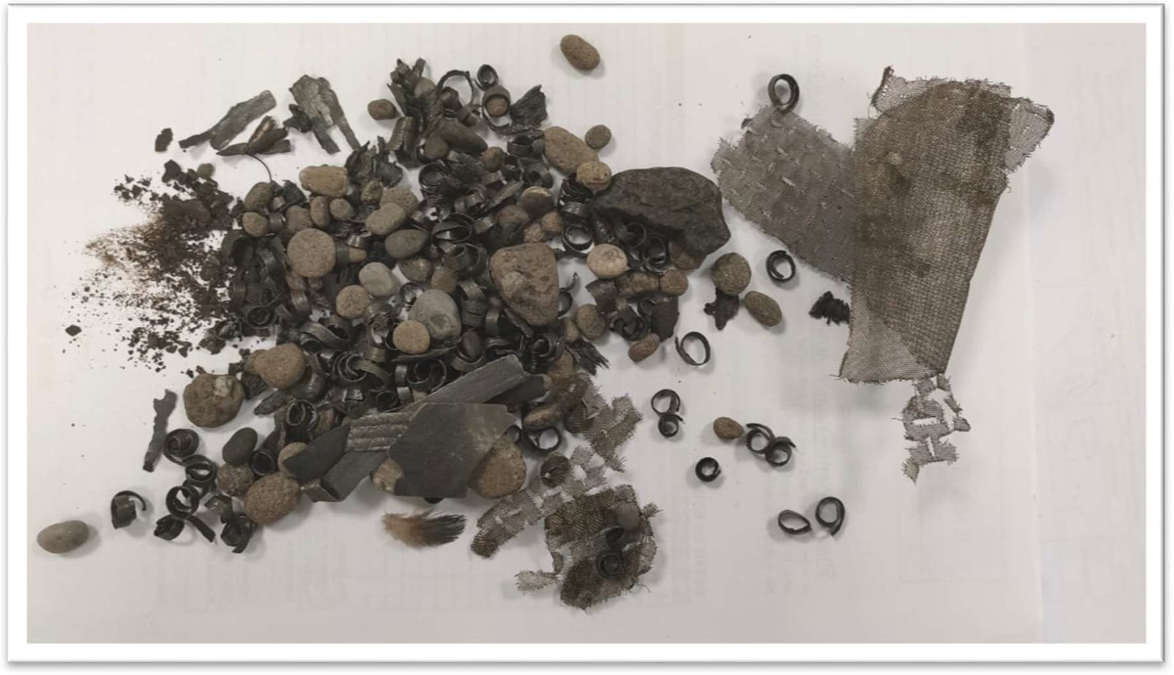

Figure 11.1: Debris found after removing valve.

* + - 1. Gas Reducing and Metering Station valves X 4. Please see Table D
         1. Removal of valve and its components.
         2. Inspection of valve components.
         3. Repair and refurbishment of valve components.
         4. Pressure testing of valves.
         5. Re-installation of valves.

Table D: KKS numbers.

R1EKD12AA001 R1EKD12AA002 R1EKD11AA001 R1EKD11AA002

Special Findings:

Replacement of soft components.

Valves pressure tested and found satisfactory. Recommendation:

a. Prepare critical spares for the valves which will be overhauled for the next outage.

* + - 1. Overflow tank isolation valve X 10. Please see table E.
         1. Cold Cutting of old valve.
         2. Welding of new valve.

c. Radiography of weld joints.

d. Final checks of valve.

Table E: KKS numbers.

|  |  |  |  |
| --- | --- | --- | --- |
| R1QJA36AA501 | R1QJA35AA501 | R1QJA43AA501 | R1QJA50AA501 |
| R1QJA44AA501 | R1QJA51AA501 | R1QJA48AA501 | R1QJA52AA501 |
| R1QJA48AA501 | R1QJA52AA501 | R1QJA46AA501 | R1QJA45AA501 |
|  |  |  |  |

* + - 1. MOVs and Control Valves X 12. Please see Table F.
         1. Dismantle valve.
         2. Inspection and repair of valve components.
         3. Replacement of wear parts.
         4. Lapping of seats and plugs.
         5. Installation of valve and testing.

Table F: KKS numbers.

|  |  |  |  |
| --- | --- | --- | --- |
| R1LBP10AA001 | R1LAB38AA001 | R1LBP40AA001 | R1HAF12AA153 |
| R1LAB11AA151 | R1HAF11AA151 | R1HAF12AA151 | R1LBA10AA501 |
| R1LBA10AA501 | R1HAF11AA001 | R1LAB22AA501 | R1LCA25AA501 |

Special Findings:

Lapping were carried out on all valves after inspection based on findings.

Replacement of soft components.

R1HAF11AA151 and R1HAF12AA151 installed in wrong orientation. Recommendation:

a. Re-position from vertical to horizontal for valve R1HAF11AA151 and R1HAF12AA151 during next major outage.

Please ref. Annexure 4c for detailed NICO report.

* + - 1. Steam Traps isolation drain valve replacement X 12. Please see table G.
         1. Cold Cutting of old valve.

b. Welding of new valve.

c. NDT of weld joints.

1. Post weld heat treatment.
2. Final NDT of weld joints.

Table G: KKS numbers.

|  |  |  |  |
| --- | --- | --- | --- |
| R1HAN15AA701 | R1HAN15AA702 | R1HAN32AA725 | R1HAN17AA701 |
| R1HAN17AA702 | R1HAN34AA701 | R1HAN34AA702 | R1HAN36AA701 |
| R1HAN36AA702 | R1HAN40AA701 | R1HAN40AA702 | R1HAN32AA702 |

* + 1. Contractors Involved
       1. NICO International.
       2. Adyard LLC.
       3. International Inspection Services.

* + 1. Recommendations
       1. To check available spares inventory and order required amount well before the next minor and major outage.
       2. OEM must implement critical equipment services.

Please refer Annexure 4 a, c & e for more details.

## Pumps

* + 1. The following Pumps considered for overhauling.
       1. Feed water pump.
          1. KKS: R1LAC22AP001.
       2. Main Recirculation pump

a. KKS: R1JD_16AP001.

* + - 1. Condensate pump.
         1. KKS: R1LCB21AP001.
      2. HTF heater pump
         1. KKS: R1JDA17AP001.
      3. HTF API pump

a. KKS: R1JD_10AP002.

Brief scope of works

1. Removal of pump.
2. Dismantling and inspection of pump components.
3. Replacement of wear parts.
4. Installation of pump.
5. Final commissioning and testing.

* + 1. Contractors Involved
       1. NICO International.

* + 1. Findings
       1. NICO could not overhaul the feed water pump 22 successfully due to insufficient technical detailed drawings and lack of experience. This pump will be overhauled by Flowserve (OEM) before end of year 2020.
       2. Spare parts ordered for the overhauling of the feed water pump 22 was mismatched with the OEM drawing due to incorrect position / part numbers. This problem has been resolved after the outage.

Ref. Annexure 4 c for detailed report.

* + 1. Recommendations
       1. To check available spares inventory and order required amount well before the next minor and major outage.
       2. OEM should implement critical equipment services. Ref. Annexure 4 a & e for detailed reports.

## Heat Exchangers

* + 1. The following exchangers inspected during outage.
       1. Low Pressure Heaters X 2
          1. KKS: R1LCC10AC001.
          2. KKS: R1LCC20AC001.
       2. High Pressure Pre Heaters X 3
          1. KKS: R1LCC30AC001.
          2. KKS: R1LCC40AC001.
          3. KKS: R1LCC50AC001.
       3. Solar Steam Generator Pre-Heater X 1
          1. KKS: R1HAC12BC010.
       4. Solar Steam Generator Evaporator X 1
          1. KKS: R1HAD11BC010.
       5. Solar Steam Generator Super heater X 1
          1. KKS: R1HAF12BC010.
       6. Ullage Heat Exchanger X 1
          1. KKS: R1QJA78AC001.

The inspection scope for the above were as follows.

1. Removal of end covers.
2. Inspection of heat exchanger’s tubes. DPT of heat exchanger tubes.
3. Hydro jet cleaning of tubes.
4. Eddy current testing of heat exchanger tubes.
5. Final inspection and box up.

* + 1. Contractors Involved
       1. NICO International.
       2. Abu Dhabi Oil Field Services (Hydratight)
       3. Serck Services
       4. International Inspection Services.

* + 1. Findings
       1. All LP & HP heater equipment can work safely without any expected failure due to an existing detrimental mechanism, within coming four years.
       2. Minor oxygen and corrosion pitting were found in most of the SSG equipment however, it is not critical due to the cyclic operations of Shams.

* + 1. Recommendations
       1. After four years from inspection, eddy current testing & borescope inspection must be planned on sample tubes of the heat exchangers to ensure integrity of the tube bundles. There is no requirement to order new tube bundles at this time.
       2. The mechanical and chemical feed water treatment should be reviewed to improve its function to avoid an increase of oxygen pitting corrosion in these heat exchangers.
       3. Contract an external audit on the water treatment at Shams.

Ref. Annexure 4 d & e for detailed reports.

## Tanks and Vessels

* + 1. The following tanks and vessels inspected during outage.
       1. Solar Steam Generator 1 & 2 Drums.
          1. KKS: R1HAE11BB010.
          2. KKS: R1HAE12BB010.
       2. Deaerator.
          1. KKS: R1LAB38AA001.
       3. Blowdown tank.
          1. KKS: R1HAN50BB010.
       4. Atmospheric blowdown tank.
          1. KKS: R1HAN10BB010.
       5. Flash tank.
          1. KKS: R1MAG01BB001.
       6. Ullage tank X 1.
          1. KKS: R1QJA80BB01.
       7. Air-cooled condenser rows X 5.
          1. KKS: R1MAG10AH001-MF.
          2. KKS: R1MAG20AH001-MF.
          3. KKS: R1MAG30AH001-MF.
          4. KKS: R1MAG40AH001-MF.
          5. KKS: R1MAG50AH001-MF.
       8. GRMS boiler X 2.
          1. KKS: R1GHC01BG001-MF.
          2. KKS: R1GHC02BG001-MF.
       9. Auxiliary boiler.

a. KKS: R1QH_10AC001.

* + - 1. Booster Heaters Radiant & convection zones X 2.
         1. KKS: R1LBA01BC001.
         2. KKS: R1LBA02BC001. 11)ST Exhaust duct.

a. KKS: R1MAG1020304050AH001.

12)HTF Heaters, radiant & convection zone X 7. a. KKS: R1JF_01BC001.

b. KKS: R1JF_02BC001.

c. KKS: R1JF_03BC001.

d. KKS: R1JF_04BC001.

e. KKS: R1JF_05BC001.

f. KKS: R1JF_06BC001.

g. KKS: R1JF_07BC001.

The inspection scope for the above were as follows.

•

Internal visual checks & NDT Inspections.

* Findings and repairs.
* Internal Cleaning.
* Final inspection and closed manholes access.

* + 1. Contractors Involved
* International Inspection Services.

* + 1. Findings
* Booster heaters 1 & 2 convection zone were found with sulfur deposits.
* Booster heaters 1 & 2 refractory found loose.
* No major findings in the tanks and vessels based on the chemical treatment that is currently followed.
* Minor oxygen pitting and corrosion pitting were found however, it is not critical due to cyclic operation of Shams.
  + 1. Recommendations
       1. Booster heater 1 & 2 & HTF heaters convection zone needs to be re-inspected at the next opportunity with proper removal of accumulated deposits.
       2. Booster heater 1 & 2 refractory require repair or replacement at the next opportunity.
       3. The mechanical and chemical feed water treatment should be reviewed to improve its function to avoid an increase of oxygen pitting corrosion in these heat exchangers.

Ref. Annexure 4 d, e & h for detailed reports.

## Filters & Strainers

* + 1. Mechanical filter replacements carried out for the following.
       1. HTF Duplex filters.
       2. HTF Heater system.
       3. HTF Main Recirculation system
       4. HTF Overflow system.

* + 1. Contractors Involved

No Contractors were involved.

* + 1. Findings

1. General wear and tear of the filters due to its usage. All filters replaced.
2. New strainer of 5 mm size installed on main recirculation pump R1JD_12AP001.

* + 1. Recommendations

a. To check available spares inventory and order required amount well before the next minor and major outage.

Ref. Annexure 4 e for detailed reports.

## Main Transformer – 165 MVA

* + 1. Summary

General inspection, cleaning and electrical testing was carried out for R1BAT10 Main Transformer.

Transformer was checked for oil leaks, damages on bushings, cable termination hotspots, local control panel condition and silica gel for breathers were replaced. Function test of protective devices were also carried out.

Following electrical tests were carried out to check integrity of mechanical and electrical components of the transformer:

* + - 1. Insulation Resistance Test (LV-E)
      2. Sweep Frequency Response Test (LV)
      3. Tan Delta and Capacitance Measurement (LV-E)
      4. Oil and Winding Temperature Indicator Calibration Tests

Prior to plant Outage, Oil and Dissolved Gas Analysis Tests were carried out as part of six- monthly condition monitoring plan of Main Transformer.

* + 1. Contractors Involved
       1. Turbine Services and Solutions (Sanad Powertech)
       2. Al Mahasin Electrical Contracting Company LLC

* + 1. Findings

In general, overall condition of 165MVA Main Transformer is satisfactory. Electrical tests and Protective device function tests were found normal.

Cooling fans were cleaned, silica gel for dehydrating breather replaced and touch-up painting done on unpainted welded joints along Conservator tank piping.

LV bushings were inspected and cleaned. HV side surge arrester, voltage transformer and earthing connections were inspected and cleaned. HV side SF6 gas density indication found normal.

HV side SF6 gas compartment degassing was not carried out due to unavailability of spare gaskets, hence, several electrical tests for high voltage winding was not carried out. These tests will be carried out in the next opportunity, meanwhile the required spare parts will be procured and kept in stock.

Ref. Annexure 4 b, e & f for detailed reports.

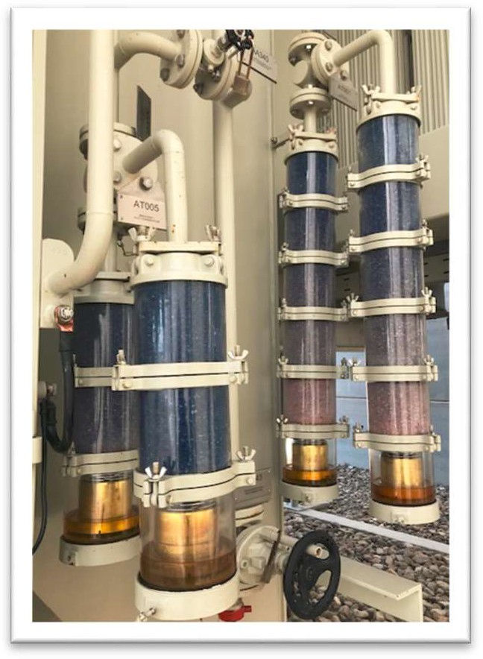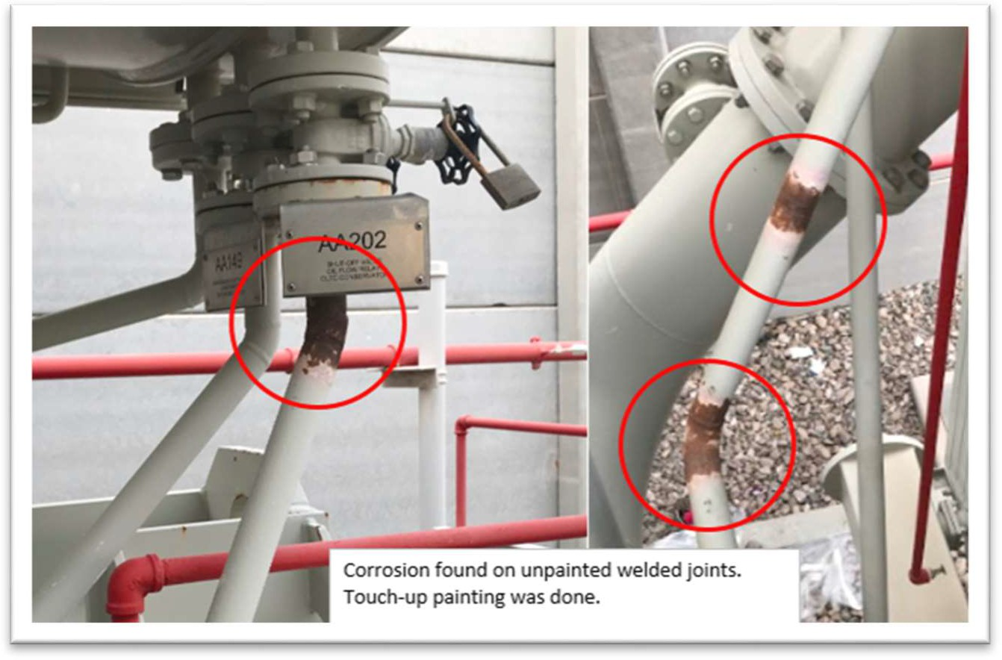

Figure 12: Silica Gel before replacement.

Figure 13: Corrosion found welding joints.

* + 1. Recommendations
       1. It is recommended to carry out Electrical testing on High Voltage winding side on the next opportunity. Spare gaskets has to be made available, support required for proper degassing, and gassing of SF6 gas insulated compartment.
       2. Check available spares inventory and order required amount well before the next minor and major outage.

## Unit Auxiliary Transformer – 25 MVA

* + 1. Summary

General inspection, cleaning and electrical testing was carried out for R1BBT10 Unit Aux. Transformer.

Transformer was checked for oil leaks, damages on bushings, cable termination hotspots, local control panel condition and silica gel for breathers were replaced. Function test of protective devices were also carried out.

Following electrical tests were carried out to check integrity of mechanical and electrical components of the transformer:

* + - 1. Insulation Resistance Test (HV-E, HV-LV, LV-E)
      2. Sweep Frequency Response Test (HV and LV)
      3. Voltage Ratio and Magnetizing Current Test
      4. Short Circuit and Impedance Test
      5. Tan Delta and Capacitance Measurement (LV-E)
      6. Winding Resistance Test (HV and LV)
      7. Oil and Winding Temperature Indicator Calibration Tests.

Prior to plant Outage, Oil and Dissolved Gas Analysis Tests were carried out as part of six- monthly condition monitoring plan of Main Transformer.

* + 1. Contractors Involved
       1. Turbine Services and Solutions (Sanad)
       2. Al Mahasin Electrical Contracting Company LLC

* + 1. Findings

In general, overall condition of 25MVA Unit Auxiliary Transformer is Satisfactory.

Electrical tests and Protective device function tests were found normal. Cooling fans were cleaned and silica gel for dehydrating breather replaced.

HV bushings were inspected and cleaned. LV cable termination compartment was inspected and cleaned. Neutral grounding Resistor was inspected and cleaned.

Ref. Annexure 4 b & e for detailed reports.

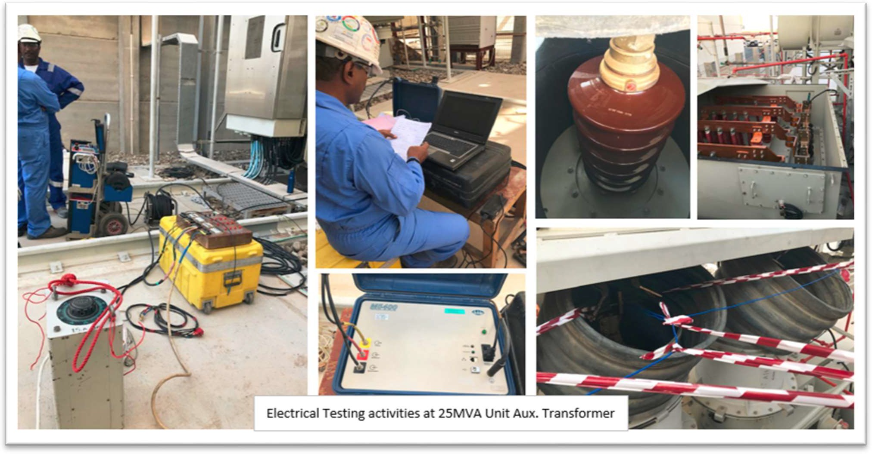

Figure 14: Electrical testing activities.

5.8.3 Recommendations

Recommend to continue Oil and Dissolved Gas Analysis as condition monitoring of transformer.

## Protection relays test for Generator, Transformer and MV / LV switchgear

* + 1. Summary

Protection relay function test was carried out for Generator, Transformer and switchgear to ensure protection are active and operating as per design. General inspection, Metering accuracy tests and protection function tests were carried out.

* + 1. Findings

Overall, Protection relays were found normal and operating as per design.

Some settings need to be reviewed and confirmed as per recommendation from vendor.

* + 1. Recommendations
       1. Some settings need to be reviewed and confirmed as per recommendation from vendor.
       2. Check available spares inventory and order required amount well before the next minor and major outage.

Ref. Annexure 4 b & e for detailed reports.

## UPS Batteries

* + 1. Summary

Battery discharge / Capacity test was carried out for UPS Battery of Main Electrical Building, Control Building and Solar Field. Cleaning and top-up of demineralized water was done after test.

* + 1. Contractors Involved
       1. Turbine Services and Solutions (Sanad Powertech)
       2. Al Mahasin Electrical Contracting Company LLC

* + 1. Findings

Overall, the UPS battery capacity was within normal range. The designed Amp-hr capacity was sufficient to supply load in a specified period of time. Several individual battery cells have gone below 1.0V/cell and these cells will be replaced.

* + 1. Recommendations

To check available spares inventory and order required amount well before the next minor and major outage.

To replace the battery cells found unsatisfactory during the discharge tests. Ref. Annexure 4 b & e for detailed reports.

## Motors

* + 1. The following scope of works carried out for Medium Voltage during the major outage.
       1. Medium Voltage Motors.
          1. Feed water pump motors X 3.

KKS: R1LAC21BWA001_MIEC.

KKS: R1LAC22BWA001_MIEC.

KKS: R1LAC23BWA001_MIEC.

* + - * 1. HTF Main recirculation pump motors X 4

KKS: R1JD_12BWA001_MIEC.

KKS: R1JD_14BWA001_MIEC.

KKS: R1JD_16BWA001_MIEC.

KKS: R1JD_18BWA001_MIEC.

Scope carried out.

Cleaning of Motors and coolers.

Inspection of Variable Frequency Drives.

Electrical tests such as Tan Delta, Insulation Resistance, etc.

Bearing oil replacement for HTF pump motors.

Re-greasing for FWP motors.

Electrical cable tests.

Preventative maintenance on associated circuit breakers.

* + - 1. Low Voltage Motors.
         1. Lube oil pump motor A.

KKS: 01MAV11BWA010_MIEC.

* + - * 1. Main Plan 54 recirculation pump motor X 2.

KKS: R1JD_10BWA001_MIEC.

KKS: R1JD_10BWA002_MIEC.

* + - * 1. Closed cooling water pump 41 motor.

KKS: R1PGB41BWA001_MIEC.

* + - * 1. Booster heater combustion air blower fan motor X 2.

KKS: R1QD_10BWA001_MIEC.

KKS: R1QD_20BWA001_MIEC.

* + - * 1. FGR Booster heater fan motor X 2.

KKS: R1QD_12BWA001_MIEC.

KKS: R1QD_22BWA001_MIEC.

* + - * 1. Condensate extraction pump 21 motor.

KKS: R1LCB21BWA001_MIEC. Scope carried out

Bearing replacements.

Electrical tests, winding resistance, insulation resistance tests.

Run out checks.

Dynamic balancing checks.

Solo run tests.

Preventative maintenance on associated circuit breakers.

* + - 1. Low Voltage motors (in-house activities)
         1. Steam Turbine Turning Gear motor.

KKS: 01MAK10BWA010_MIEC.

* + - * 1. Lube oil pump motor B.

KKS: 01MAV12BWA010_MIEC.

* + - * 1. Emergency Lube oil pump motor.

KKS: 01MAV13BWA010_MIEC.

* + - * 1. Control oil pump motor A.

KKS: 01MAX11BWA010_MIEC.

* + - * 1. Lube oil tank vapor extractor motor.

KKS: 01MAV07BWA010_MIEC.

Scope carried out

General cleaning of motor body.

Inspection of motor terminal box.

Tightness checks of cables.

Insulation and winding resistance tests.

Preventative maintenance on associated circuit breakers.

* + 1. Contractors Involved
       1. NICO International.
       2. Turbine Service and Solutions (Sanad).
       3. Al Mahasin Electrical Contracting Company LLC.

5.11.3 Findings

1. Casting of new aluminum cooling fan for Condensate extraction pump motor.
2. Loose bearing housing on LV motors. Re-sleeving implemented.
3. Variable Frequency drive cooling fans found seized and bearing were replaced.
4. Minor sand and dust were found accumulated in motor body.

* + 1. Recommendations
       1. To check available spares inventory and order required amount well before the next minor and major outage.
       2. Procure and store spare motor cooling fans in stock.

Ref. Annexure 4 a, b & e for detailed reports.

## Electrical Cables rectification works.

Cables that were found hanging and out of cable tray around Steam turbine building and HTF area were dressed and fixed accordingly.

Cables were fixed back to cable trays and secured by UV rated, PVC coated steel cable ties. Ref. Annexure 4e for detailed report.

## Instrumentation works.

* + 1. Summary
       1. Booster Heater 1 radiant in section path temperature elements replacement. X 10
          - Removal of the Temperature Transmitter and defected Thermocouples.
          - Grinding the surface and preparing the weld buttering.
          - DPT inspection.
          - Welding the new temperature elements.
          - Post Weld Heating Treatment (PWHT).
          - DPT inspection.
          - Installation and normalizing of the transmitters.
          - Confirming the healthiness of the signal and readings.

* + - 1. Booster Heater 2 radiant in section path temperature elements replacement. X 3
         * Removal of the Temperature Transmitter and defected Thermocouples.
         * Grinding the surface and preparing the weld buttering.
         * DPT inspection
         * Welding the new temperature elements
         * Post Weld Heating Treatment (PWHT)
         * DPT inspection
         * Installation and normalizing of the transmitters
         * Confirming the healthiness of the signal and readings.
      2. Data analysis of flow from HP-PH2 to check the reliability of its outlet flow meter, R1LEC40CF001.
         * Vortex Flowmeter (S/N: D1L901266), Flow Converter (S/N: D1L901271) were sent to YOKOGAWA for calibration.

* + - 1. Instrumentation support works such as disconnections and reconnections of instruments for various equipment undergoing maintenance were provided. Final stroking of MOVs & Control valves were implemented in coordination with operations.
    1. Contractors Involved
       1. YOKOGAWA for Calibration of flowmeter.
       2. International Inspection Services.
       3. Aries Oil Field Services.

* + 1. Findings
       1. Many control cables insulation and trays found broken and in bad condition. Please see Fig. 14.1.
       2. Steam and Water sampling stations needs to be recommissioned in the next major outage as many instruments keeps failing due to ambient temperature and direct sunlight. Please see Fig. 14.3.
       3. Many instruments found without proper shade to protect them from direct sunlight. Please see Fig. 14.2

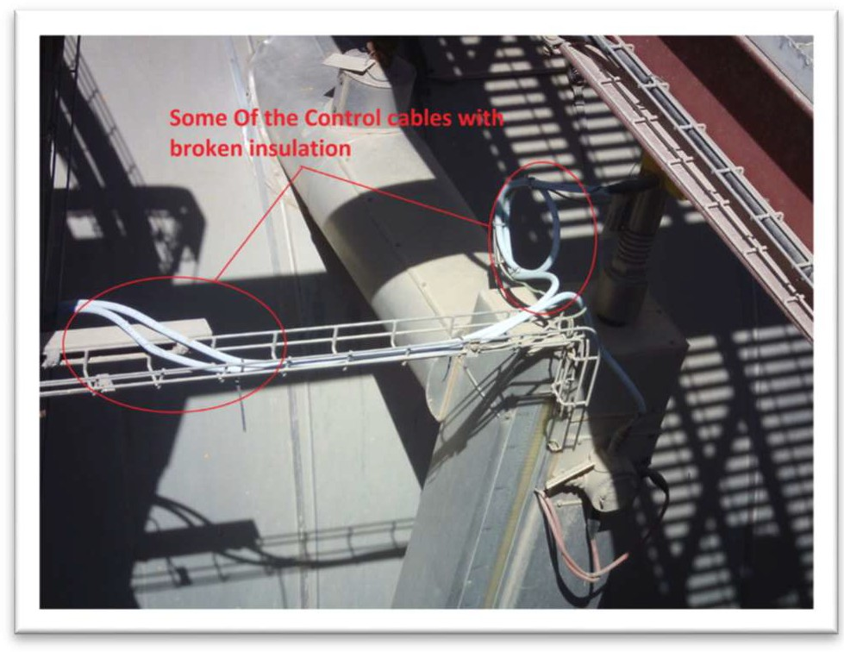 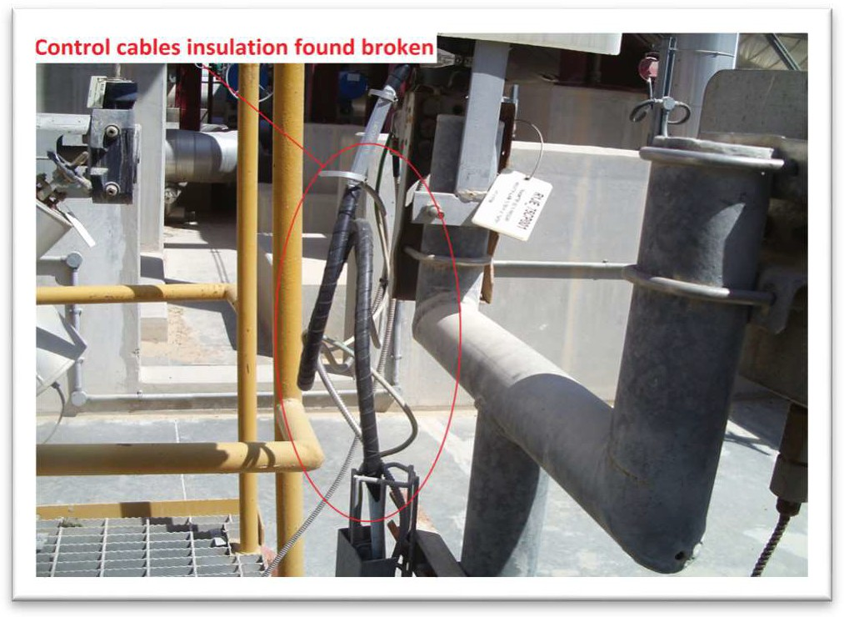

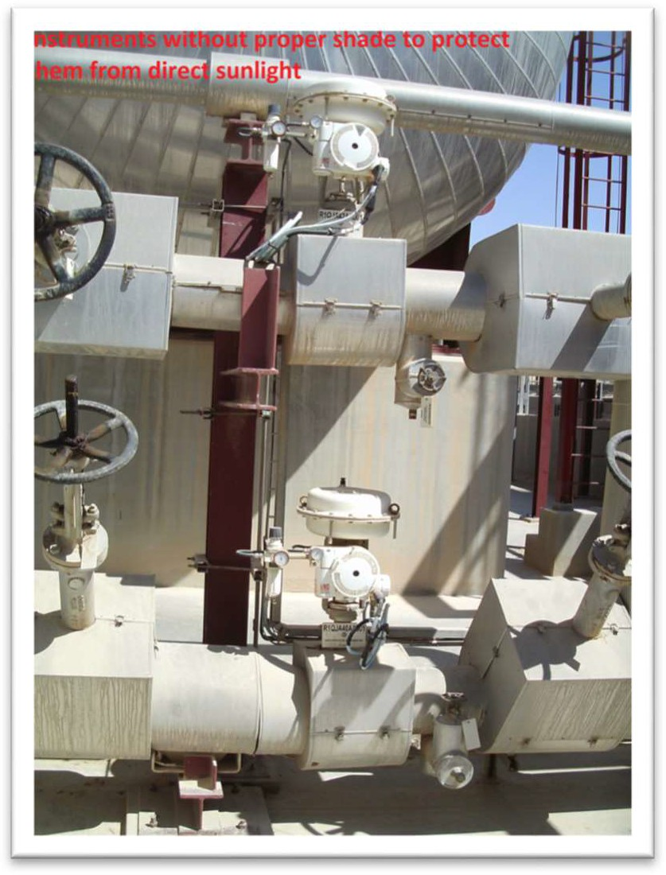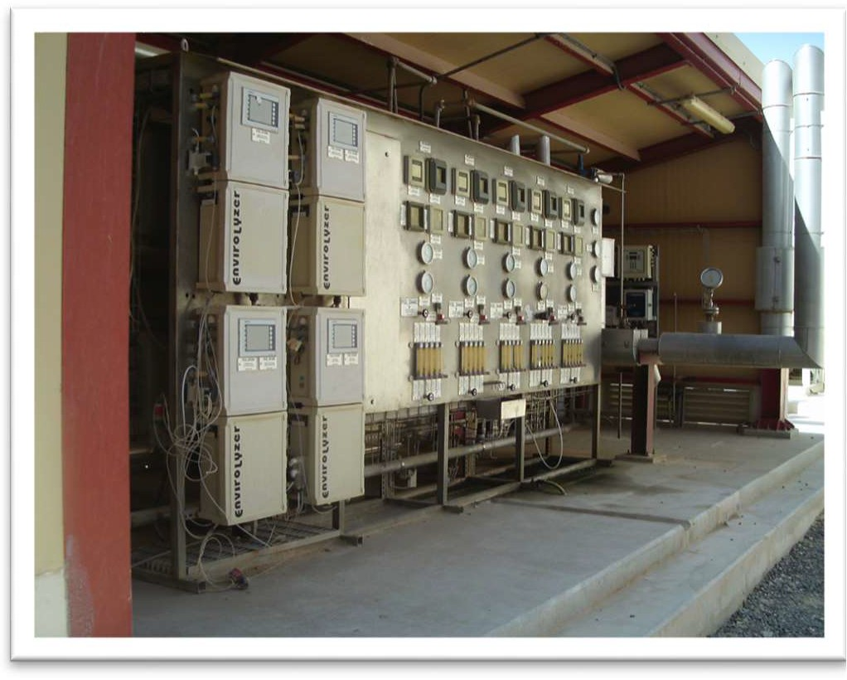Figure 14.1: Broken insulation control cables.

Figure 14.2: No Shade to protect from sunlight. Figure 14.3: Sampling station.

* + 1. Recommendations

To check available spares inventory and order required amount well before the next minor and major outage.

Ref. Annexure 4e for detailed reports.

## Bolt tightening works.

* + 1. Summary

For booster heater 1 & 2, all bolts were inspected and tightened based on the OEM manual.

* + 1. Contractors Involved
       1. NICO international.

* + 1. Findings
       1. Bolts on the booster heater spectacle flanges were replaced.

* + 1. Recommendations
       1. To check available spares inventory and order required amount well before the next minor and major outage.

Ref. Annexure 4c for detailed NICO reports.

# CHAPTER 6: SOLAR FIELD

## General

Since the entire solar field would be isolated for the major outage, here was the opportunity to replace and repair many critical components in the solar field that would require a long outage period.

The strategy was to allocate one main contractor as a lump sum contract to implement all Solar Field activates including support services such as scaffolding, insulation, crane, inspections (including radiography & Dye Penetrant) as specified in the scope of works. One company identified as shown below.

* + 1. Turbine Services and Solutions (Sanad Powertech) with their sub-contractor King City Technical Services: Responsible for all solar field activities.

Except for 768 level 3 boxes anticorrosion and painting, all solar field maintenance activities carried out including the opportunity work due to the extension of the outage caused by the steam turbine.

## Scope of Works.

Below are the scope planned for the outage.

* + 1. 242 Damage absorber tube replacement. (Fig. 16)
    2. 102 Ball joint replacement. (Fig. 15)
    3. 384 Adjustment of ball joint double supports. (Fig. 17 & 18)
    4. 32 Spools replacements. (Fig. 16)
    5. 30 Hydraulic cylinder replacements. (Fig. 19 & 20)
    6. 768 Hydraulic skid cleaning.
    7. 150 Wind breaker patching.
    8. 8 Re-coating of welding joints.
    9. 9 Pressure safety valve replacements. 10)Flow Meter Gasket replacement.

11)Replacement of the bonnet/gasket of the passing loop isolation valve in GH99-100.

An inspection scope following the insurance feedback from the Solar Field fire incident that took place in November 2019 was also included.

1)

322 Spools non-destructive testing.

2) 38 Spool radiography testing.

Opportunity scope due to outage extension also implemented.

1. 36 Absorber tubes replacements.
2. 4 Hydraulic cylinder replacements.

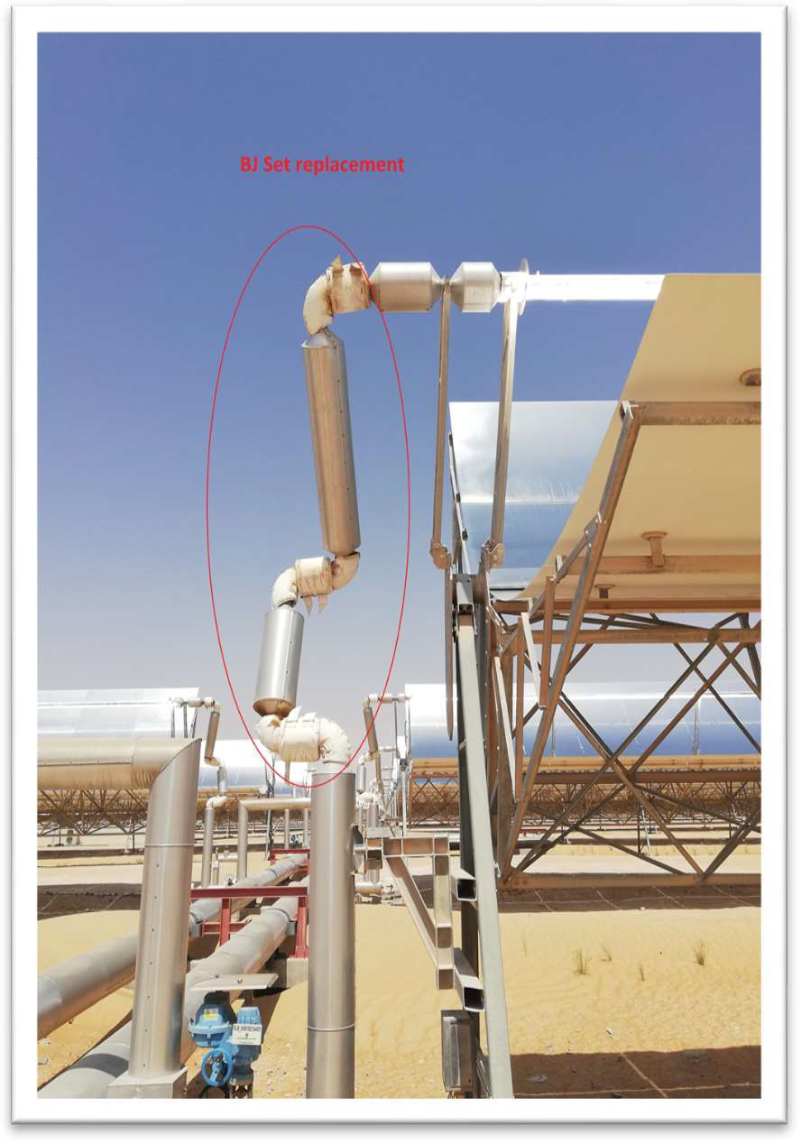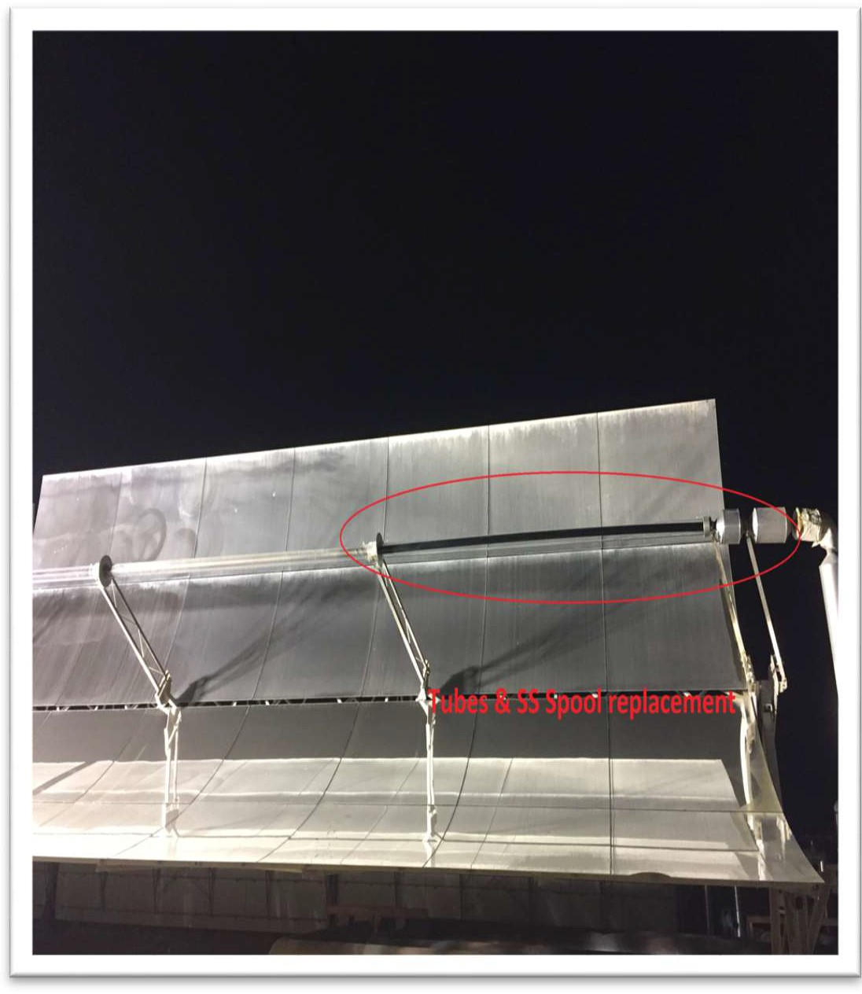

Figure 15: Ball Joint replacement. Figure 16: Tubes & SS Spools replacement.

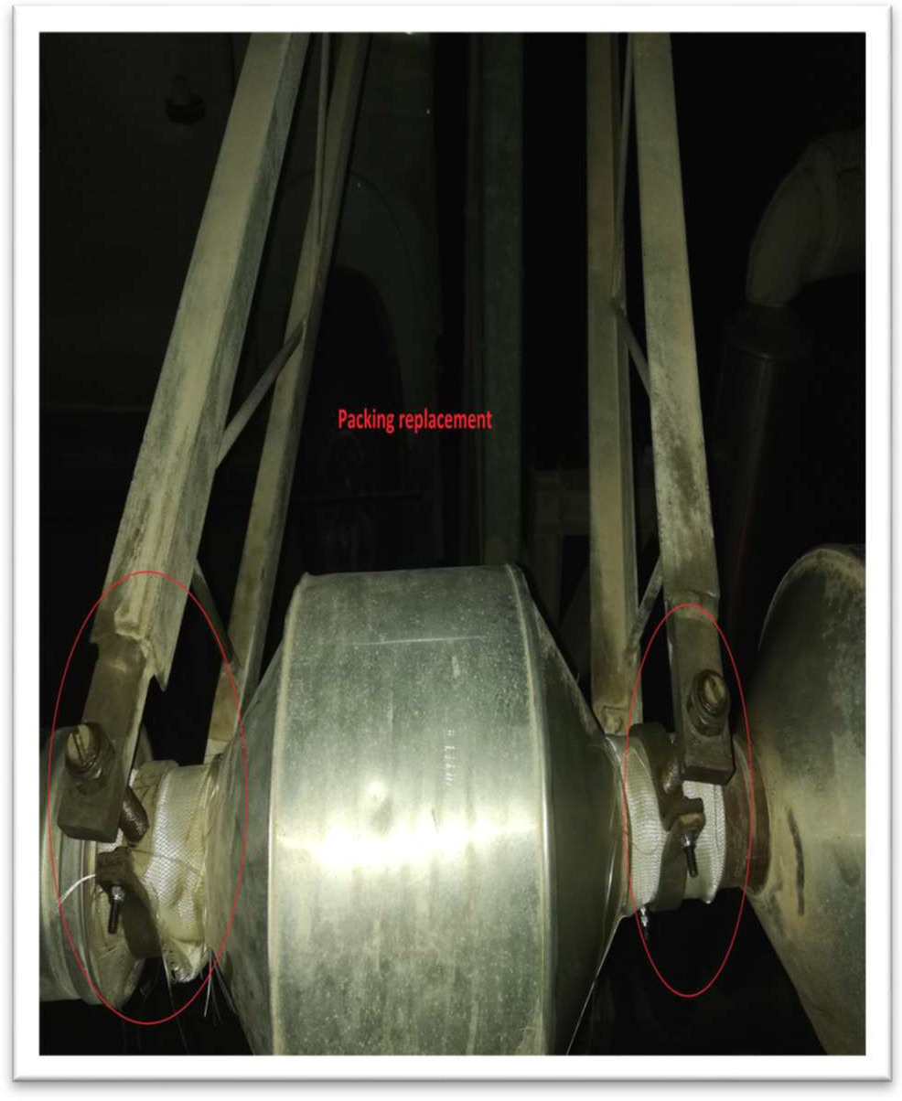 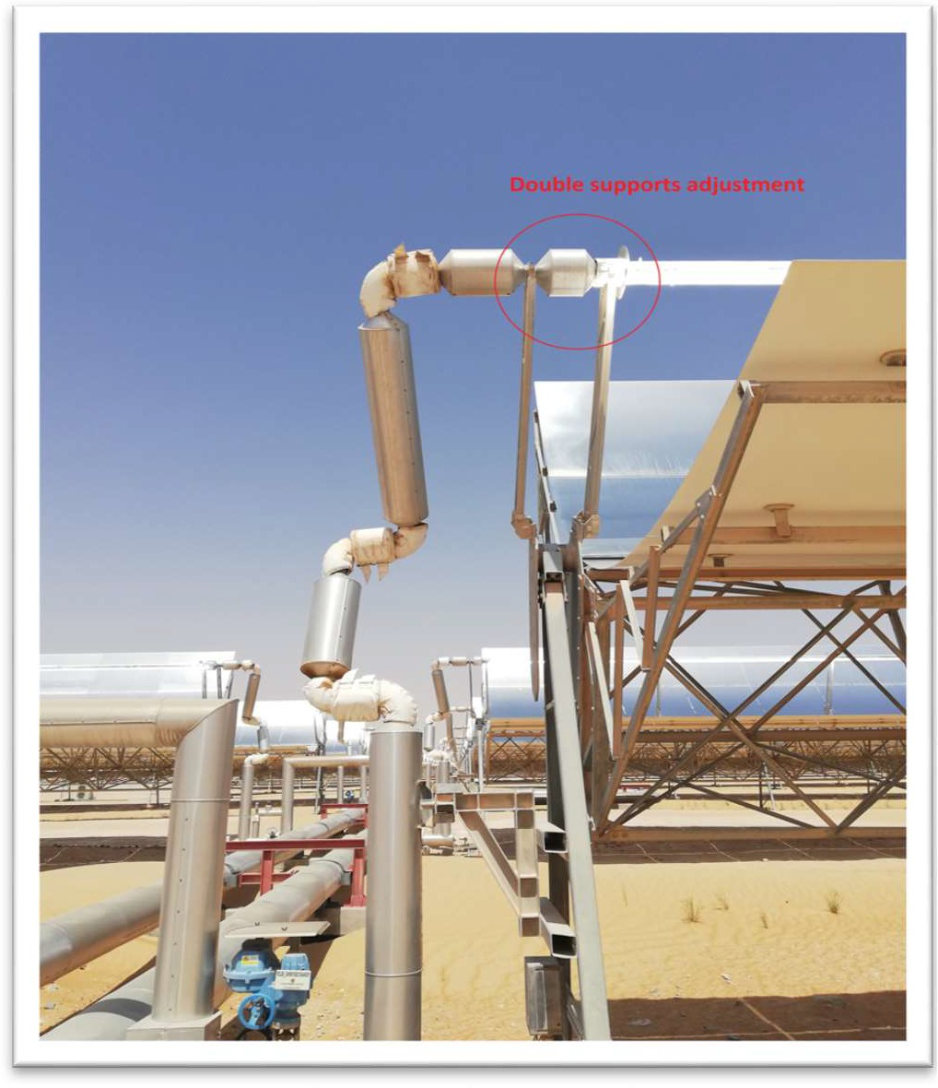

Figure 17: Ball Joint Double supports replacement. Figure 18: Tubes & SS Spools replacement.

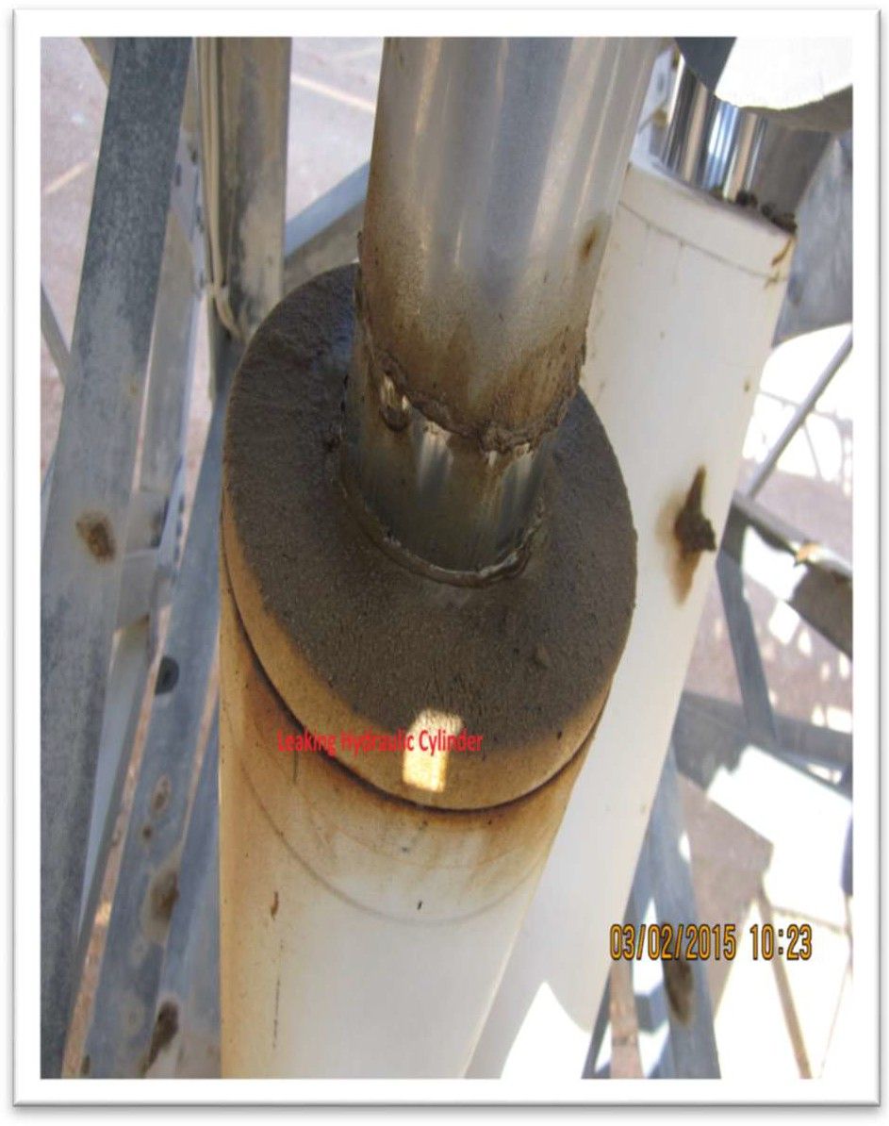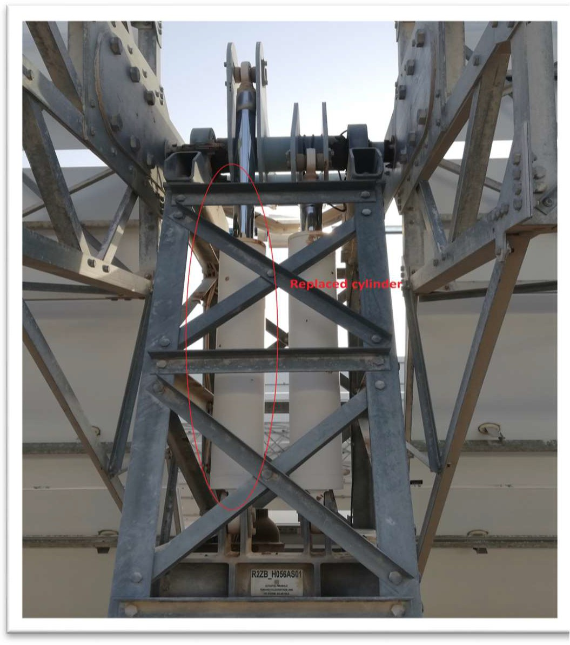

Figure 19: Leaking Hydraulic Cylinder. Figure 20: Hydraulic Cylinder replacement.

## Contractors Involved

The following are the main contractors assigned by Shams.

* + 1. Turbine Services and Solutions (Sanad).
    2. King City Technical Services.

## Findings

* + 1. Excessive foreign materials found, e.g. welding rods, stones, nuts and bolts, etc. after bonnet of the valve, R2JB_GH09910010AA501 was replaced. Please see Fig. 20.1

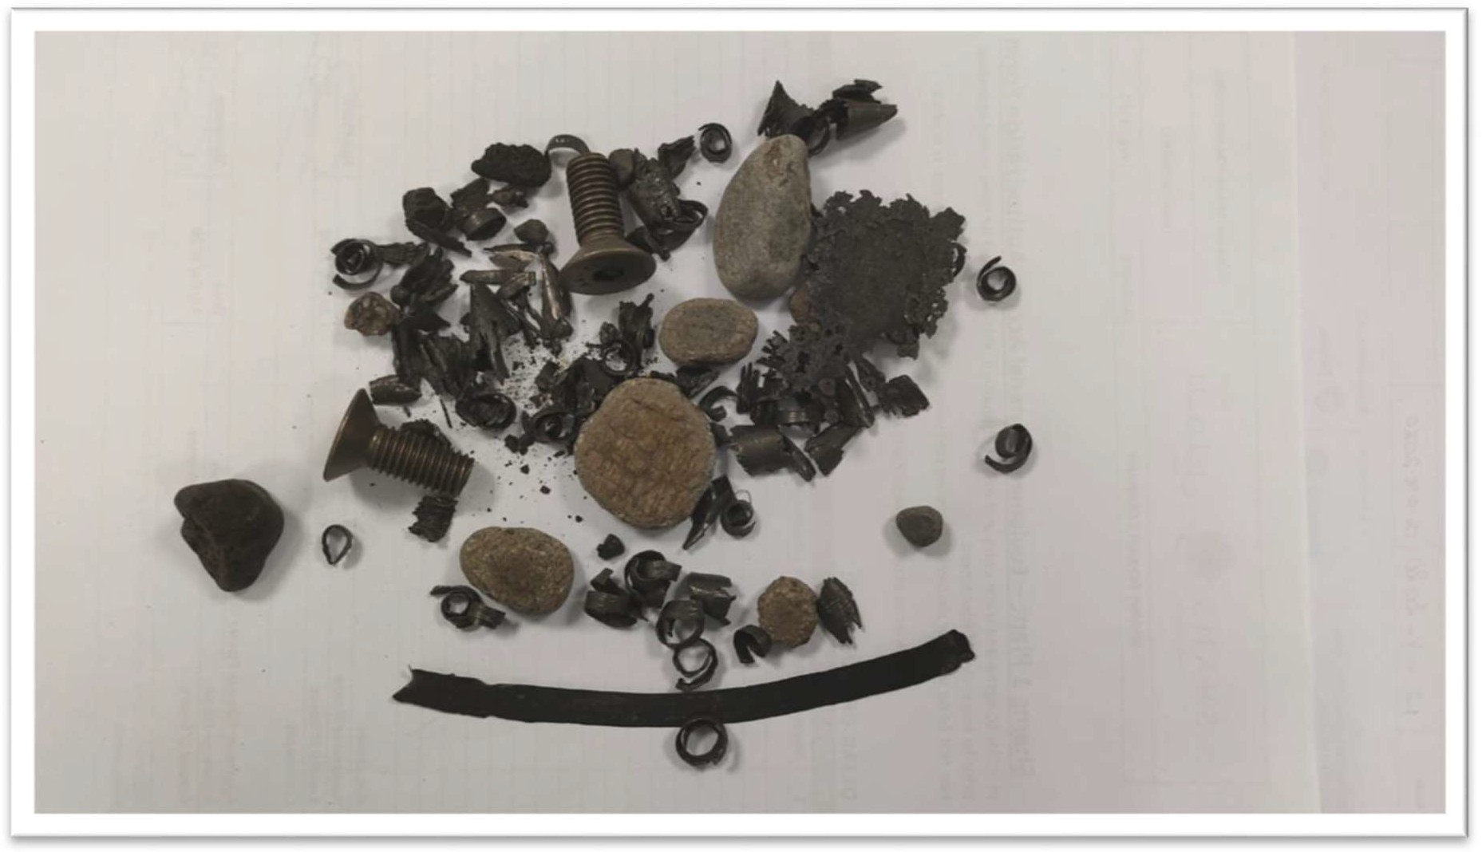

Figure 20.1: Debris found in the valve seat.

## Recommendations

* + 1. To check available spares inventory and order required amount well before the next minor and major outage.
    2. Painting and anti-corrosion of Level 3 boxes required at the next possible opportunity.
    3. HTF system to be cleaned during the next major outage.

Ref. Annexure 5 for detailed reports.

# CHAPTER 7: IMPROVEMENT PROJECTS

## Steam Turbine DCS upgrade

The OEM (MAN) informed Shams that the Steam Turbine Distributed Control System would be obsolete after the year 2020 and recommended to have the system upgraded. MAN then implemented this during the outage. The current Steam Turbine DCS upgrade has a validity of 10 years.

Ref. Annexure 3 for detailed MAN outage report.

Lead Contractor: MAN Energy Solutions.

## Air Cooled Condenser Cable modifications.

The cable route for ACC Fan motors modified from underground route to overhead road crossing through cable tray rack. The project involved erection of new structure, installation of cable trays, cable pulling, and installation of junction panels, cable termination and testing.

The project executed in two stages: Pre-outage and Outage works. All civil, foundation and structural works carried out before Outage and cable pulling, termination and testing done within outage period. One set of spare cables were also pulled from MCC to ACC top platform.

After Cable termination, the cables were tested to ensure continuity, insulation and correct phase sequence. Each fan motors were started to confirm correct direction of rotation.

After few days of keeping the fans in service, there were failures observed on some terminal blocks due to overheating. All similar terminal block types were replaced with bus-bar type terminal and no overheating was observed.

Ref. Annexure 4 e for detailed reports.

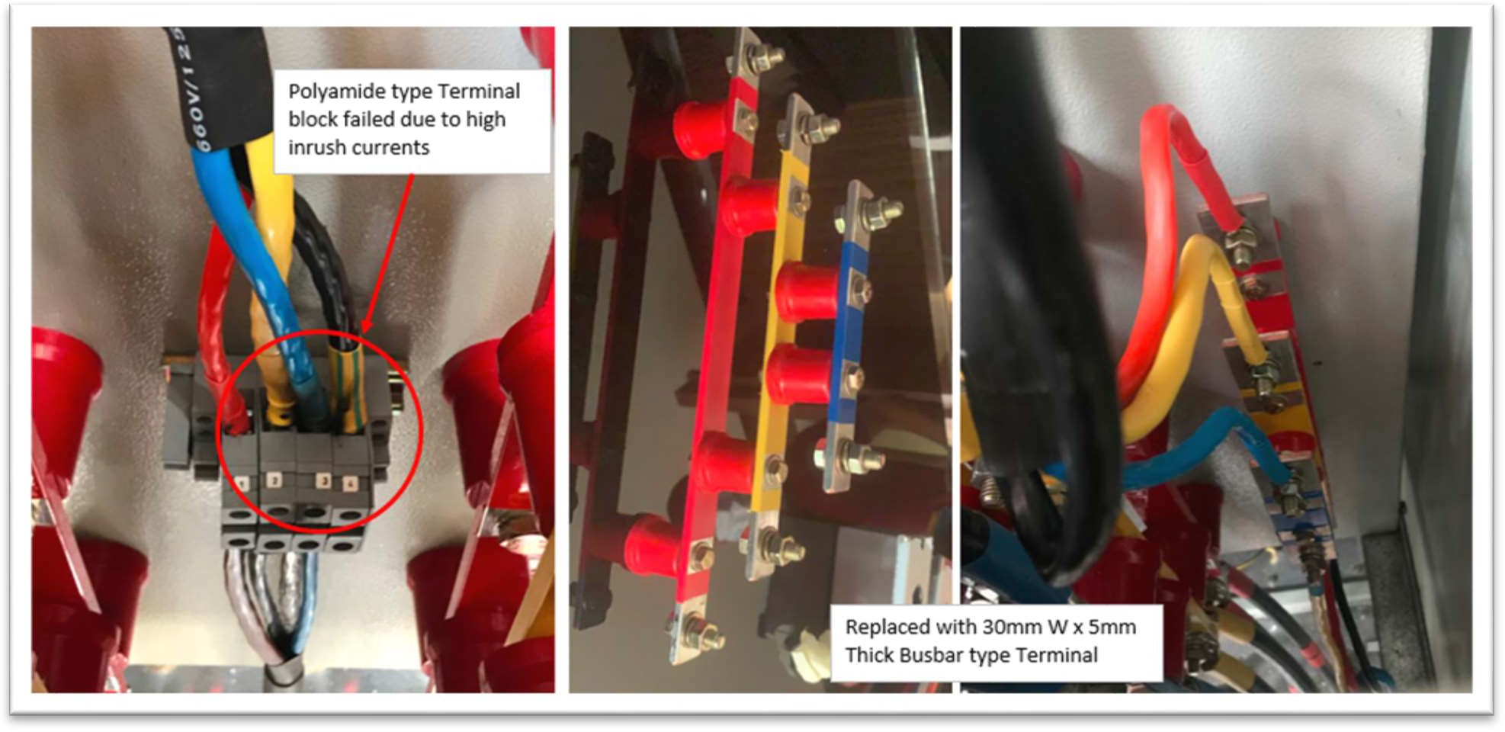

Figure 18: New cable terminations.

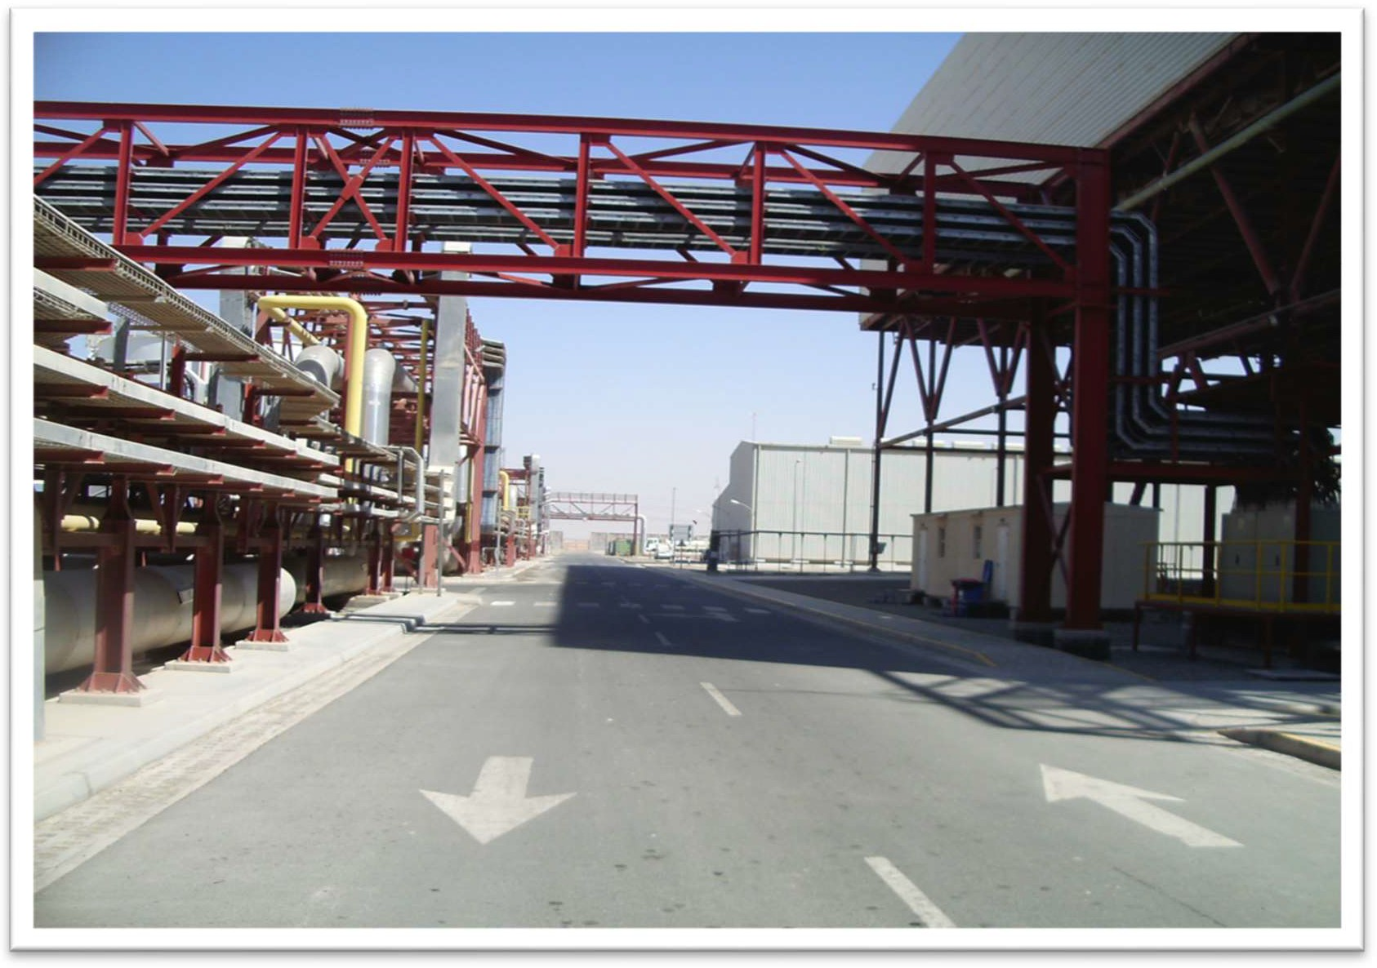

Figure 19: New cable bridge.

Lead Contractor: Dolphin Oil Field Equipment Service.

* 1. **Booster Heaters 1 & 2 design and installation of walkway platforms.** Booster Heaters 1 & 2 had no access platform in which maintenance personnel could access in order to address any technical issues. Scaffolding was always used in order to create such access, which were often time consuming and costly. Therefore, permeant platforms designed and installed during the outage period to ensure safe and permeant access.

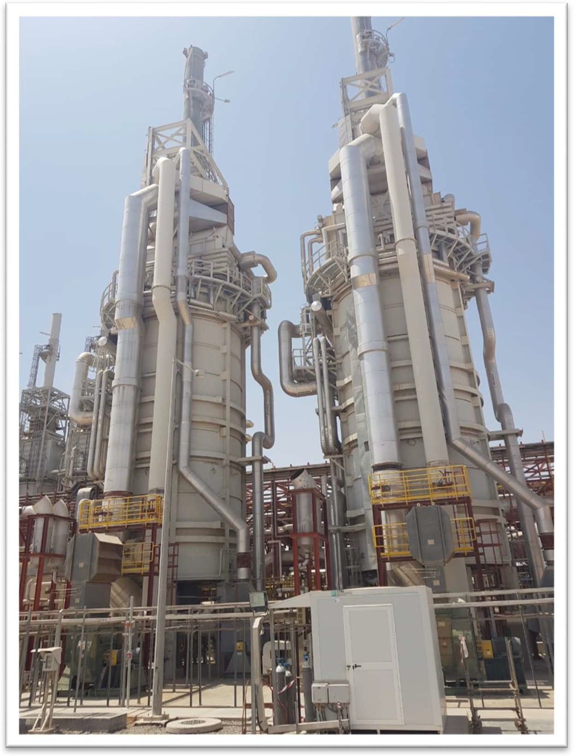

Figure 20: Booster Heater 1 & 2 permeant platforms.

Lead Contractors: Al Emain Blacksmith Workshop & Aries Oil Field Services.

## Booster Heaters 1 & 2 burner modifications and commissioning.

During the outage, pilot burner of each Booster Heater was replaced by a new higher capacity continuously running pilot burner in order to function with lower steam flow requirement. This would help evaporate the condensate inside “U” type steam tubes of Booster Heaters without much reduction in temperature of the downstream header.

For the logic modifications, during the light-off sequence, rather than an automatic transfer from igniter operation to main burner operation, when the igniter brought into service the BMS system will hold this condition giving indication of “HOT STANDBY MODE”. Air control devices must hold in minimum light-off positions. Following a ten-second delay, an option will provide to site operators to “TRANSFER TO MAIN BURNER”. This option would continue the already programmed transition sequence to main burner operation. After this transition, the system will release to modulate per current logic. A flame scanner signal must be maintained during all modes or otherwise the system should initiate a trip.

To conclude, this modification will save Shams’ gas consumption in HTF-Heaters, used in Booster Heaters and supply supper heated steam to the Steam Turbine more efficiently.

Lead Contractors: John Zink Company LLC & Siemens LLC.

* 1. **HTF Heater – Alternative Communication Network Upgrade.** Communication among seven Panel Logic Controllers (Siemens) of HTF-Heaters and Distrusted Control System established through another PLC (Schneider) which was causing slow and overloading of communication traffic and poor reliability of communication architecture. Therefore, a new Alternative Communication Network (A.C.N) installed would get the communication direct from DCS to heaters’ PLCs (Siemens).

During 2020 outage, one out of seven HTF-Heater PLC system directly connected to the new A.C.N and tested. The result confirmed its availability and reliability of this upgrade.

The remaining six HTF-Heaters A.C.N upgrade will be planned in subsequent outages based on budget and time available.

Lead Contractor: Valmet Seluloz Kagit ve Enerji Teknolojiler

## Steam Turbine Oil System Varnish removal unit.

Prior to the outage, the steam turbine lube oil analyzed and reported of high varnish particles however, there was no water content traceable. Therefore, three options for the steam turbine oil system considered by Shams.

Option 1: Replacement of ST lube oil = AED 595,000.

Option 2: Cleaning/Treatment of the ST lube oil by contractor = AED 70,000.

Option 3: Procure, install and commission a permanent Varnish removal unit, plus a 1 year service agreement = AED 99,550.

Management of change created for Option 3, planned and implemented during outage successfully as shown in Fig. 21.

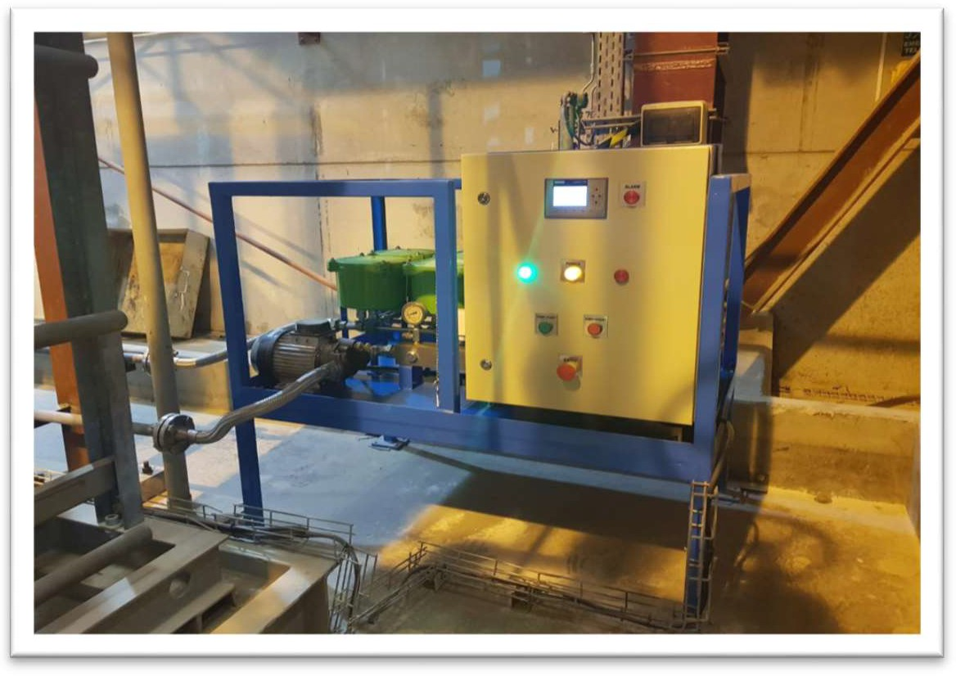

Figure 21: New Lube oil varnish removal system

Lead Contractor: Hydrocarbon Solutions International LLC

## Gas Reducing and Metering Station (GRMS) roof vents.

Following an insurance audit, there was a recommendation to install Vents in the GRMS area, however this required the entire station to shut down and the outage was the perfect opportunity. This was planned and implemented successfully during the outage period as shown in Fig 22.

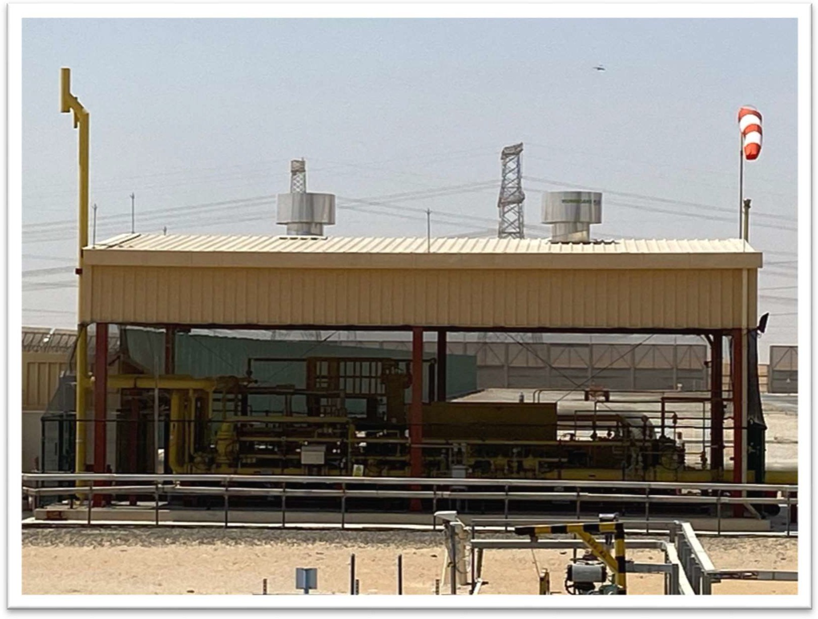

Figure 22: Installed GRMS Roof Vents.

Lead Contractor: Green Energy Solutions VEM LLC

* 1. **HTF Main pump area Overhead crane commissioning and load test** The overhead crane installed during the initial commissioning phase of the Shams plant was not load tested. During the major outage, this overhead crane was inspected, load tested and commissioned for the first time since. This proved useful in saving time and money to remove the Main HTF pump for overhauling and re-installation.

Lead contractor: NICO International.

## Steam Turbine Sprinkler System modification.

The steam turbine bearing assembly sprinkler system was partially obstructed by a lube oil pipe. This point was part of the insurers report recommendations to modify it in order to ensure a proper water distribution in case of fire. During the outage, the obstructed sprinkler head was modified through a MOC generated by HSE department.

Lead contractor: None. This was done in-house.

## Main HTF pumps deluge and Steam turbine lube oil skid foam systems actual tests.

Due to daily operations constraints, the main HTF pumps deluge and steam turbine lube oil foam suppressions systems have never been tested. During the outage these two systems were successfully tested by HSE team and normalized prior to plant start up.

Lead contractor: None. This was done in-house.

***Antonio.Antonuccio***

*2021-02-11 12:09:42*

--------------------------------------------

What about use of Ai2 Asset Integrity Platform?

**CHAPTER 8: LESSONS LEARNT**

## Documentation

Prior to the outage there were lack of some documentations which affected the preparation

and execution of the outage. These documents shown below would have provided more

clarity if available.

Drawings

* + 1. Drawings with part number identifications.
    2. Drawings required to generate lift plans prior to outage.

Procedures

Insulation procedure plus technical specifications.

1. Commissioning procedures.

1)

1. Turbine inspection protocols.
2. Loop and function check protocols.
3. Protection test procedure and protocols.

Reporting (during and after outage)

1. Detailed faultfinding report.
2. Detailed outage report.
   1. As found readings.
   2. Final settings.
   3. Spare parts consumed.
   4. Recommendations.

Lesson Learnt

Documentation must clearly specify in the RFQ during the preparation phase for the outage in

future. During review of bidding contractor companies, documentation requirements must be

evaluated.

***Antonio.Antonuccio***

*2021-02-11 12:13:17*

--------------------------------------------

don't understand

## Contingency Calculation

During the budget preparation phase for the major outage only 7% of the total outage budget  was considered with the assumption that there would be no major findings. The budget did

not account for the refurbishment cost of components and under estimation of the DCS upgrade that ended up more expensive.

Lesson Learnt

Future major outage contingency amount should be calculated based on the actual expenses records of the major outage 2020.

## Outage Duration

The outage duration based upon the assumption that the steam turbine rotor replaced with new and no major findings anticipated, following this, a 24-day schedule was prepared. However, during the outage the actual situation was very different, the technical findings were much more than expected and therefore critical path shifted to repair of these technical findings, causing the extension of the outage.

Lesson Learnt

Future major outage contingency amount should be calculated based on the actual expenses records of the major outage 2020.

## Waste Management

The outage activities have generated a huge amount of waste that has accumulated in the waste area. The accumulated waste was found not properly segregated mostly by the contractors where several incompatible wastes have been found in the same bins. Moreover, some waste was simply dumped on bare soil due to lack of waste bins.

Lesson learnt: For future outages, waste management aspect shall be clearly discussed with contractors in addition to provision of sufficient waste bins for proper segregation and disposal.

**CHAPTER 9: OUTAGE COST ANALYSIS**

## Actual vs Budget Overview

For the planned outage in March 2020 the overall budget was created as shown in table 1.

* + 1. GL 591240 Major outage 2020: Budget amount for all the planned works executed during major outage.
    2. GL 600112 Contingency / Extra work: To account for any unforeseen situations only 7% of the overall outage budget considered.

Table 1: Post Outage Budget overview (Estimated Cost vs. Budget)

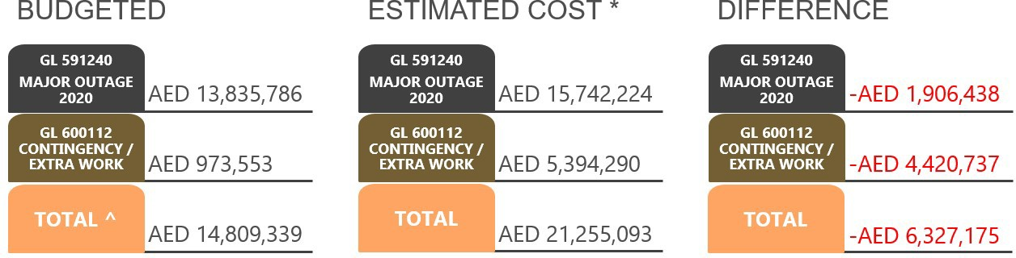

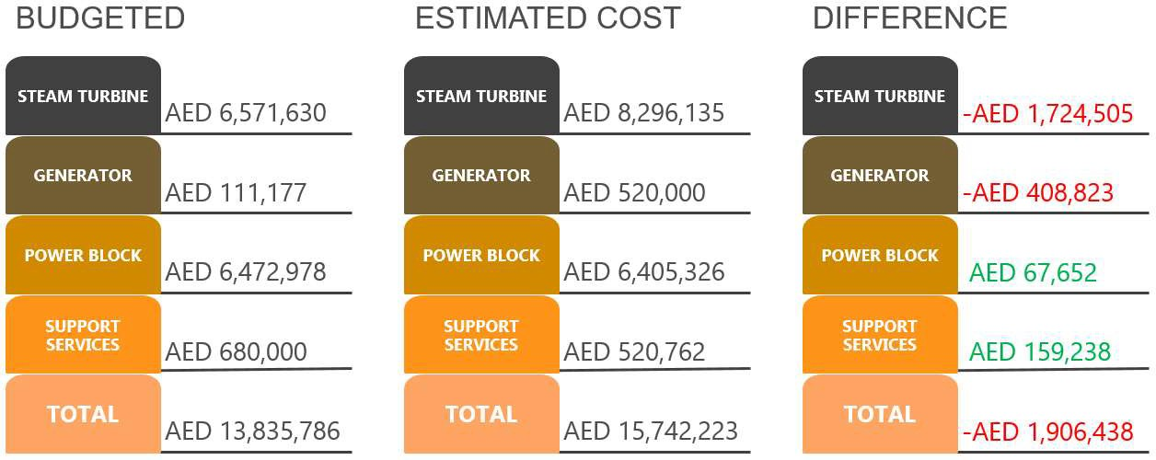Expected overrun of AED 6.33m was initially estimated. The estimation was done on a worst case scenario which was presented and approved by the Board.

*\* Estimated Costs were approximated based on existing contracts.*

*^ Budget amount does not include AED 2.25m against Rotor Refurbishment. This activity is planned for 2021*

Table 2: Post Outage Budget overview (Actual Cost vs. Budget)

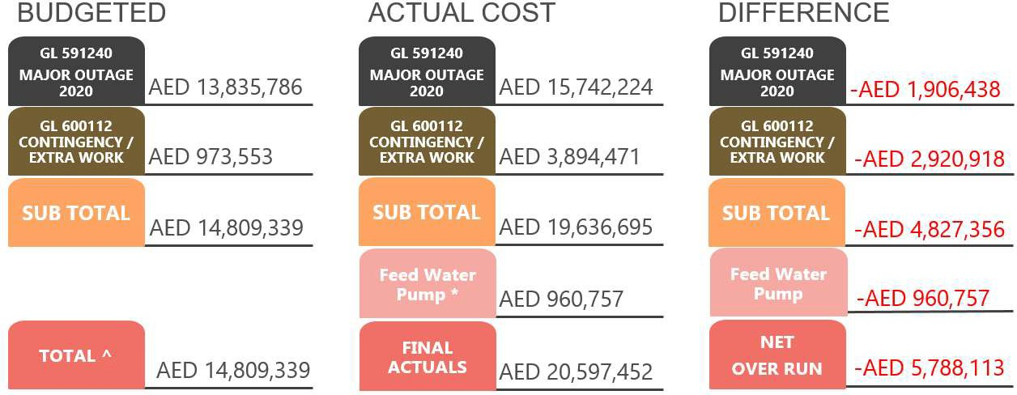

*\* Feed Water Pump overhaul being part of the Major Overhaul scope, was done by the contractor initially. However, after the overhaul the results were not satisfactory and pump was found to be under performing. Subsequently, the full overhaul was successfully performed by the OEM. The related additional cost has been capitalized as part of the Major Overhaul.*

*^ Budgeted amount does not include AED 2.25m against Rotor Refurbishment. This activity is planned for 2021*

**9.2 Reasons for Budget Over-run**

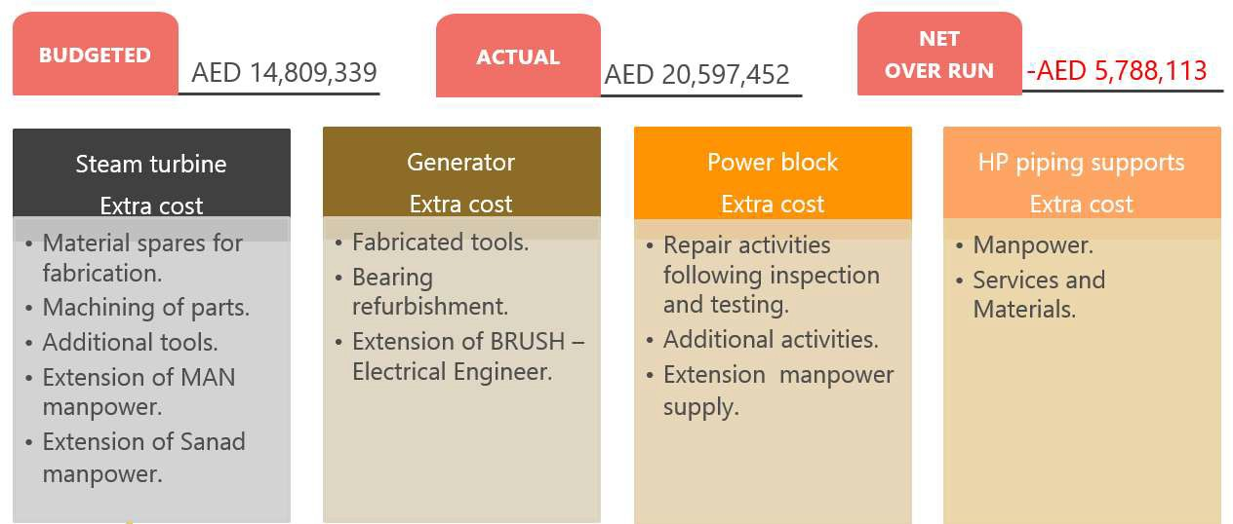

The below table shows the breakdown of four major areas of the outage works.

Table 2: Major outage 2020 breakdown

|  |  |  |  |
| --- | --- | --- | --- |
| Areas | Budget | Approx. Actuals | Difference |
| Steam Turbine | AED 6,571,630 | AED 8,296,135 | -AED 1,724,505 |
| Generator | AED 111,177 | AED 520,000 | -AED 408,823 |
| Power Block | AED 6,472,978 | AED 6,405,326 | AED 67,652 |
| Support Services | AED 680,000 | AED 520,762 | AED 159,238 |
| TOTAL | AED 13,835,786 | AED 15,742,223 | -AED 1,906,438 |

The reasons for Steam Turbine over spend was due to the following.

1. MAN supervision personnel increased from three to five persons. Following meetings with MAN prior to the outage, they informed Shams that having only three persons would mean an advisory role in which the MAN personnel would only advise rather than supervise and take responsibility for the functionality and time schedule.
2. Steam Turbine DCS upgrade cost was much more than initially anticipated.

The reasons for the Generator over spend was due to the following.

1. Initial scope planned for the generator was a minor inspection, however due the technical issues on the generator bearing, shaft (vibrations) and stator windings (temperature) the scope updated to major inspection.
2. It is making financial sense to synchronize the generator major outage with the steam turbine major outage, the duration for both are approximately the same.
3. This change in scope had no impact on outage duration but the cost increased as shown in the table 2 above.

## Contingency / Extra Works.

The extra work on the Steam Turbine consisted of the following.

* + 1. Procurement of raw materials.
    2. Fabrication of material spares.
    3. Machining of ST components.
    4. Additional tools and equipment due to findings such as the drilling machine.
    5. Extension of MAN personnel due to findings and turning gear incident.
    6. Extension of Turbine Services and Solutions (Sanad) labor due to turning gear incident.

The extra work on the Generator consisted of the following.

1. Fabrication of tools such as the 5.4Ton turfer with 20 meter wire to pull the generator rotor.
2. Refurbishment of parts like the Drive End bearing.
3. Extended stay of BRUSH engineer due to travel restrictions caused from the COVID – 19 pandemic.

The extra work on the Power Block consisted of the following.

1. Various repair activities following inspection and testing.
2. Additional activities due to extension of the outage.
3. Labor supply extension.

The HP piping supports was a major finding during the Steam Turbine outage. This required specialist personnel to survey and recommend corrective actions and hence the extra labor, support services and materials/parts were required.

# ANNEXURES

## Annexure 1: MAN Steam Turbine findings report.

## Annexure 2: Generator outage report.

* 1. Generator major outage proposal.
  2. BRUSH outage report.

## Annexure 3: MAN Steam Turbine outage report.

## Annexure 4: Power Block reports.

* 1. NICO reports.
  2. Al Mahasin reports.
  3. Adyard reports.
  4. Shams Engineering reports.
  5. Shams Maintenance reports.
  6. Visual inspection reports.

## Annexure 5: Solar Field reports.

## Annexure 6: Welding procedure for HP pipe.

## Annexure 7: Ansaldo Energia HP Piping Support report.

Please note: All reports / documents mentioned in the Annexures are available on request.